Social Media-Learning Platform

# Aim and objective:

This project aims at building a social media-learning platform to give the user the ability to manage their learning road with the perfect road map which suitable to their requests by letting the users share their experiences. Through this application, we aim to help individual learners or teachers to start their careers in a successful and informative way, after collecting user information and start recommending the most useful courses depending on user knowledge.

# Features:

1.User information page(profile)

2. User editable information

3. Recommendation system depending on user knowledge

4. Feed page for experiences and course sharing

5. Learn page to specify learner courses

6. Test page for user skills testing

7. Code page for most common codes used in the programming field

8. The ability to earn badges and points depending on user progress

# Technologies:

# Full responsive UI(not completed yet):

# HTML

# CSS3

# Font Awesome library

# Normlize Library

1. javaScript

**Completed prototype Pages :**

1. Sign up page

Overview on large screens :

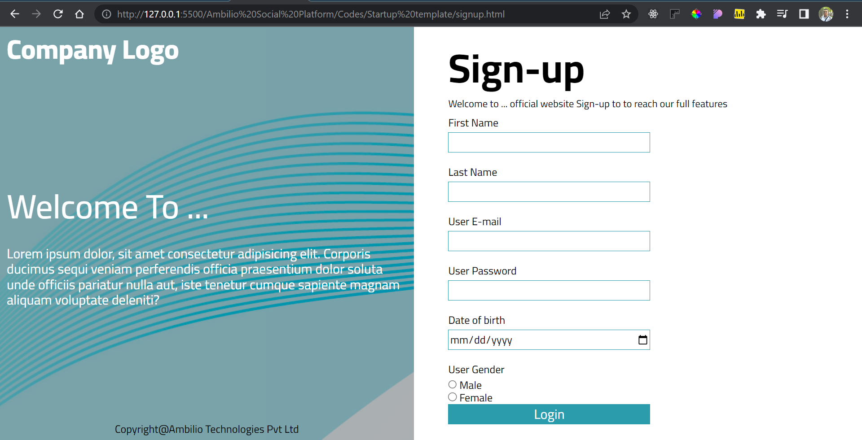

Overview on small screens :

For Example Iphone X :

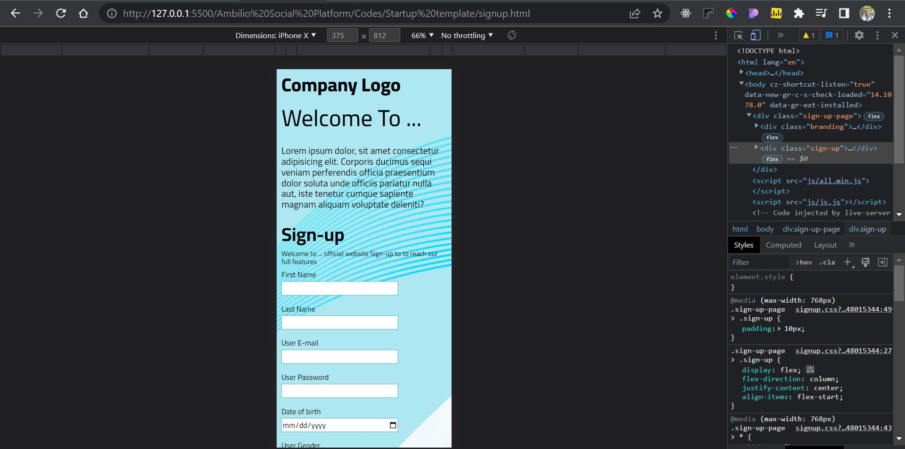

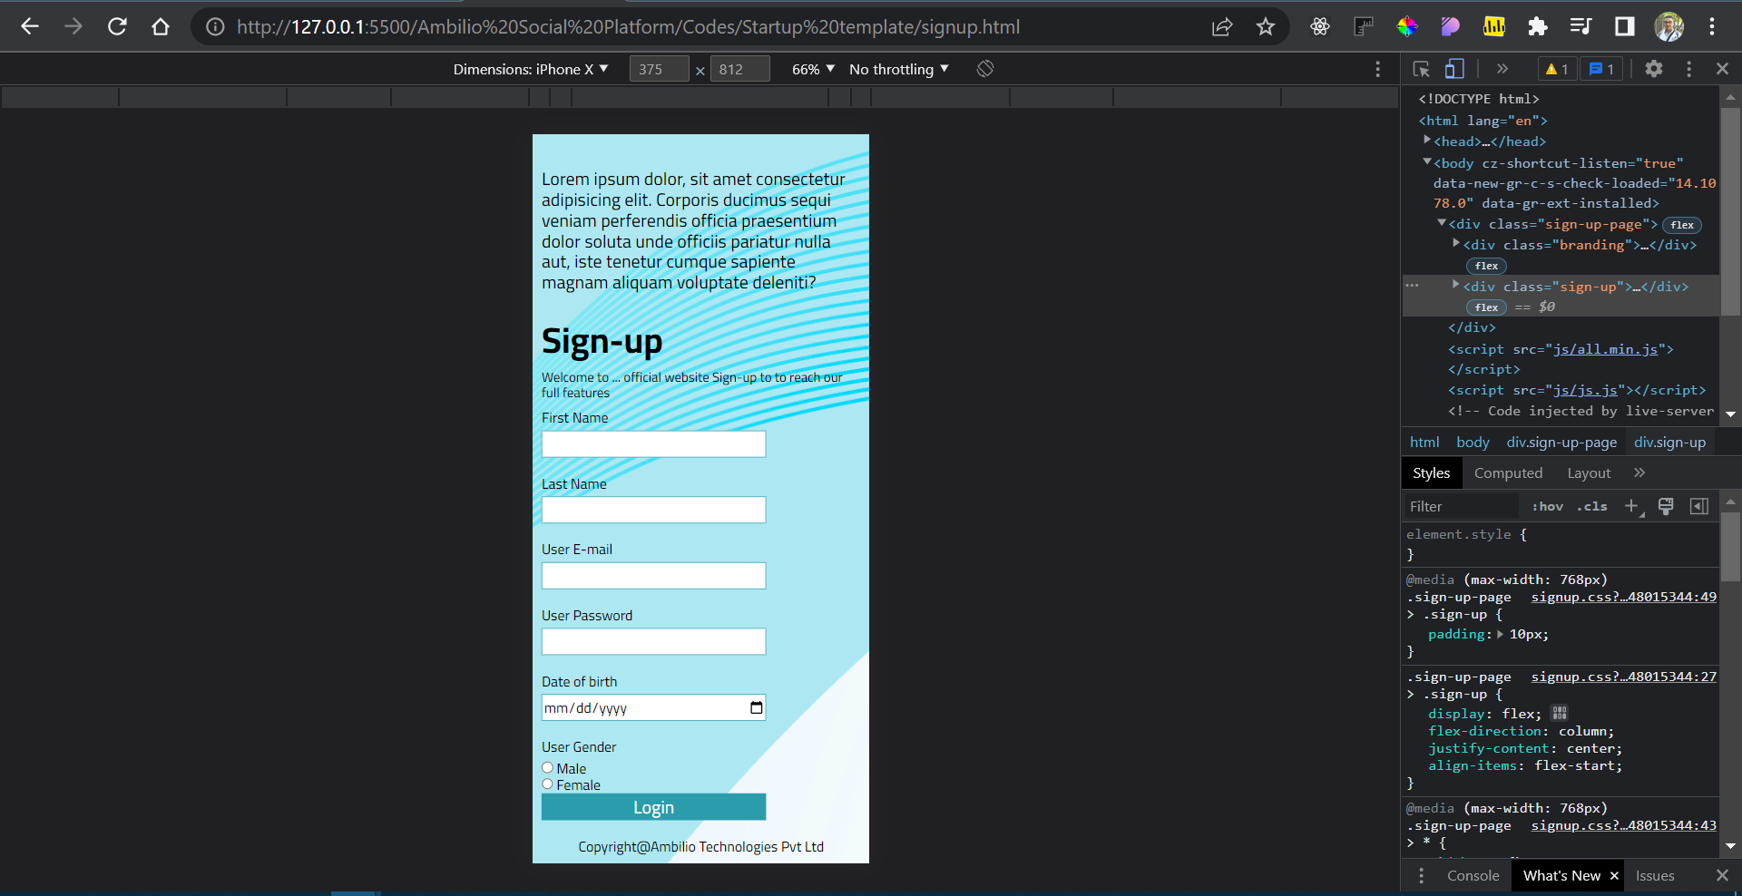

Basic Animation for Sign up page :

Shadow box on focused input field :

Unfocused :

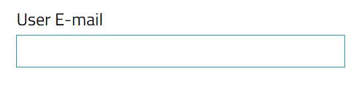

Focused :

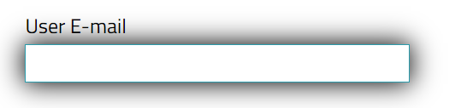

1. Log In page

Overview on large screens :

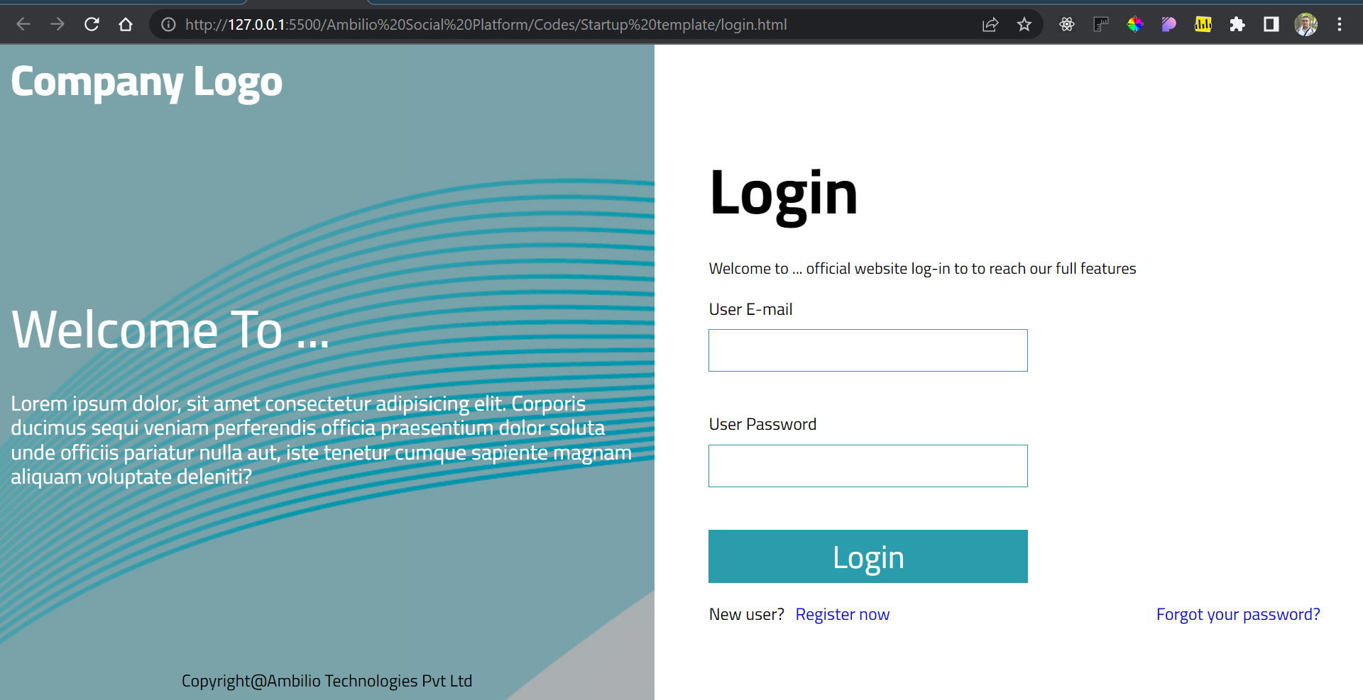

Overview on small screens :

For Example Iphone X :

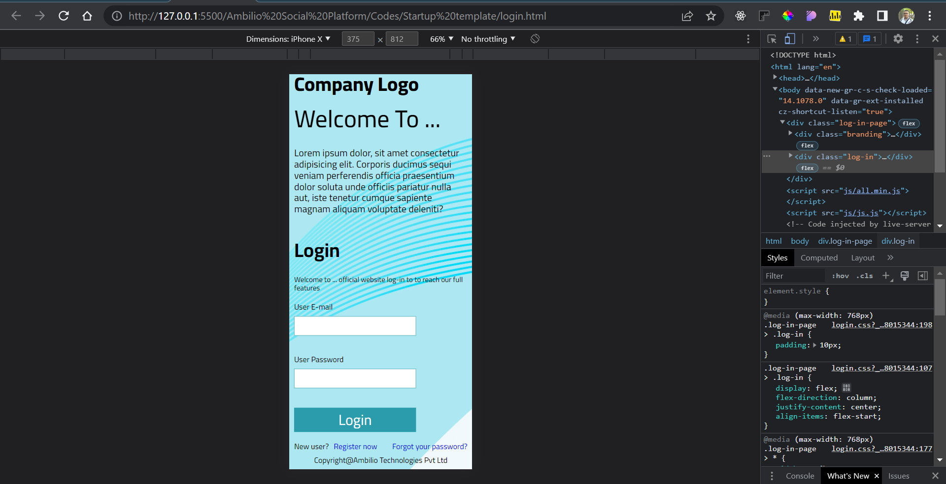

Basic Animation for Sign up page :

Shadow box on focused input field :

Unfocused :

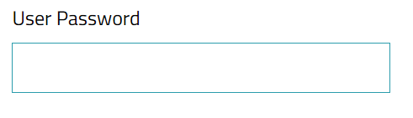

Focused :

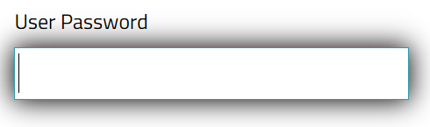

**Prototype sketch for Log-in / Sign up page :**

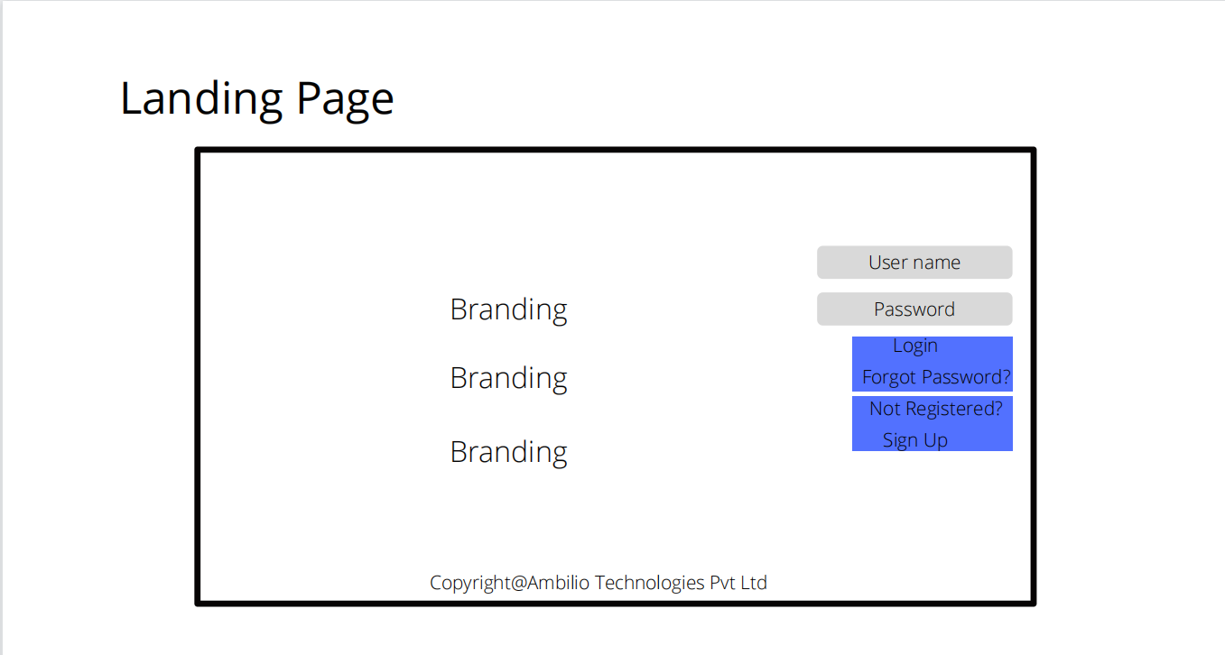

1. Feeds Page :

Demo posts with ability to scroll down only for feeds part just like Linked-In

Overview on large screens :

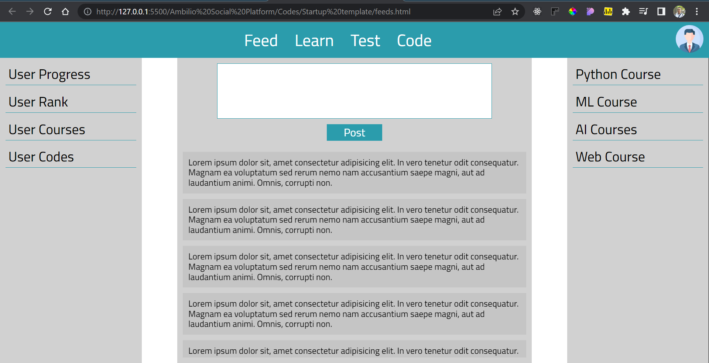

Overview on small screens :

For Example Iphone X :

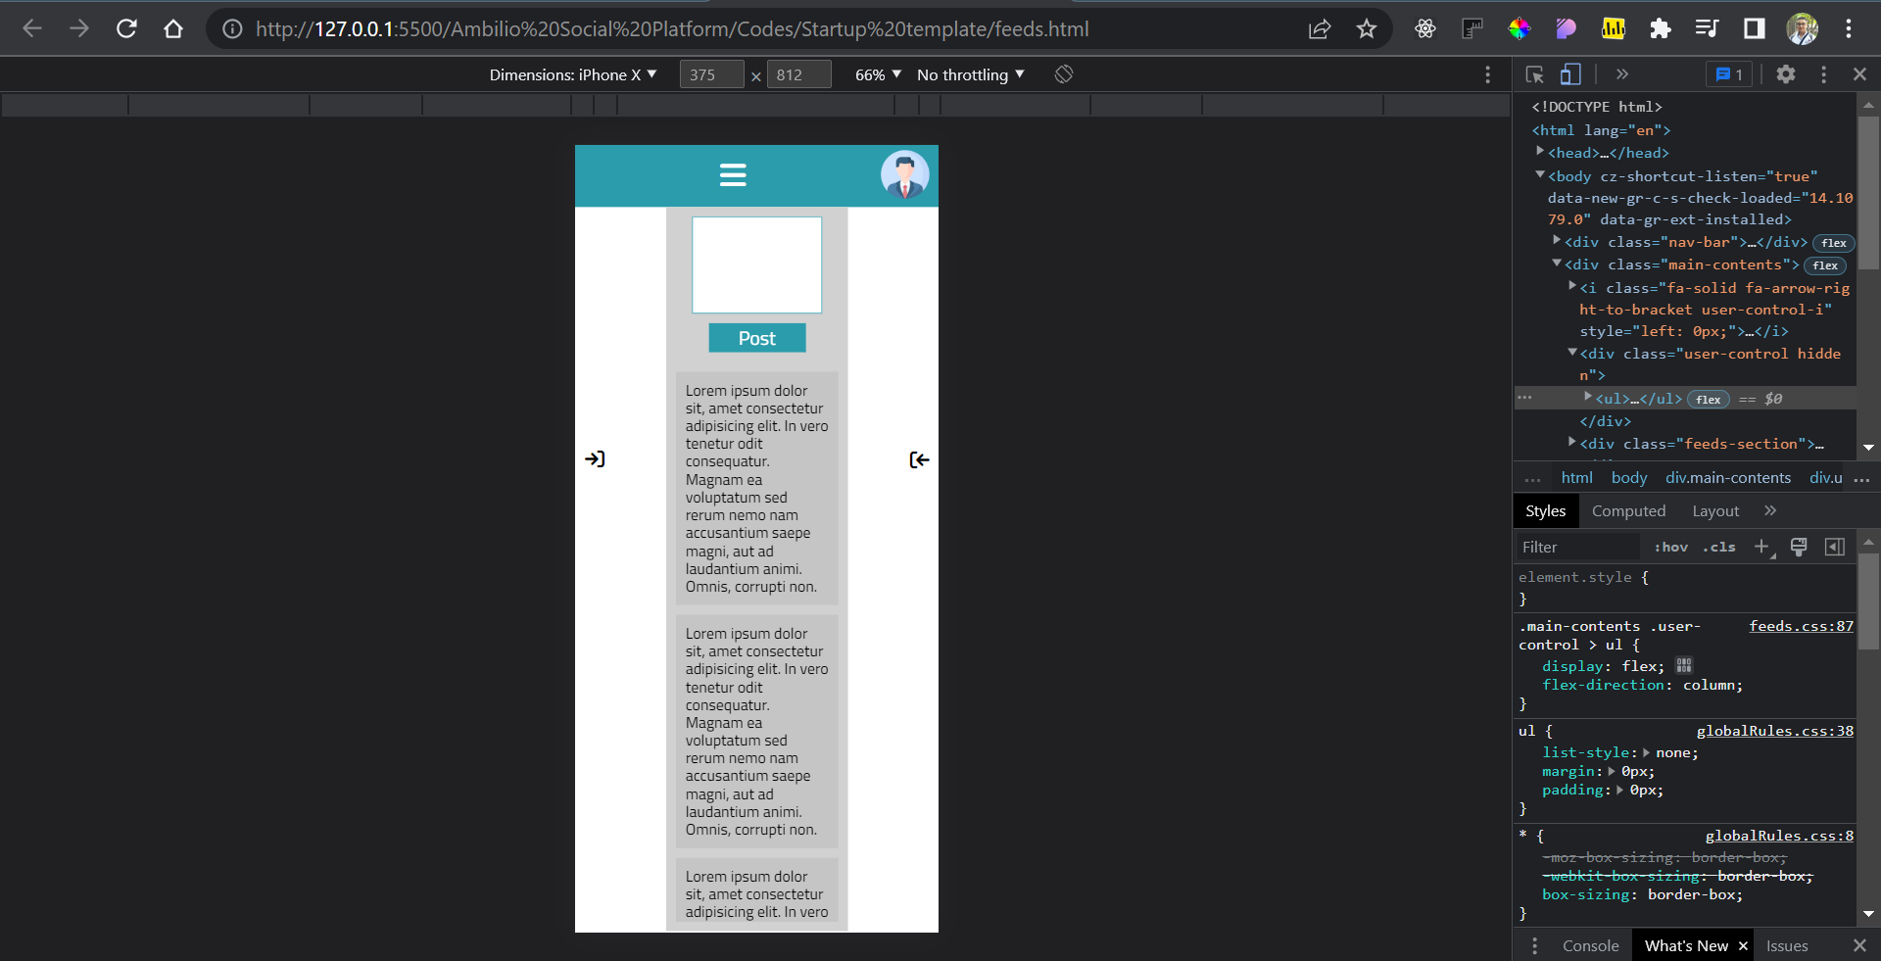

JavaScript functionality in feed page :

1. On click on the left arrow :

If the User control panel is hidden :

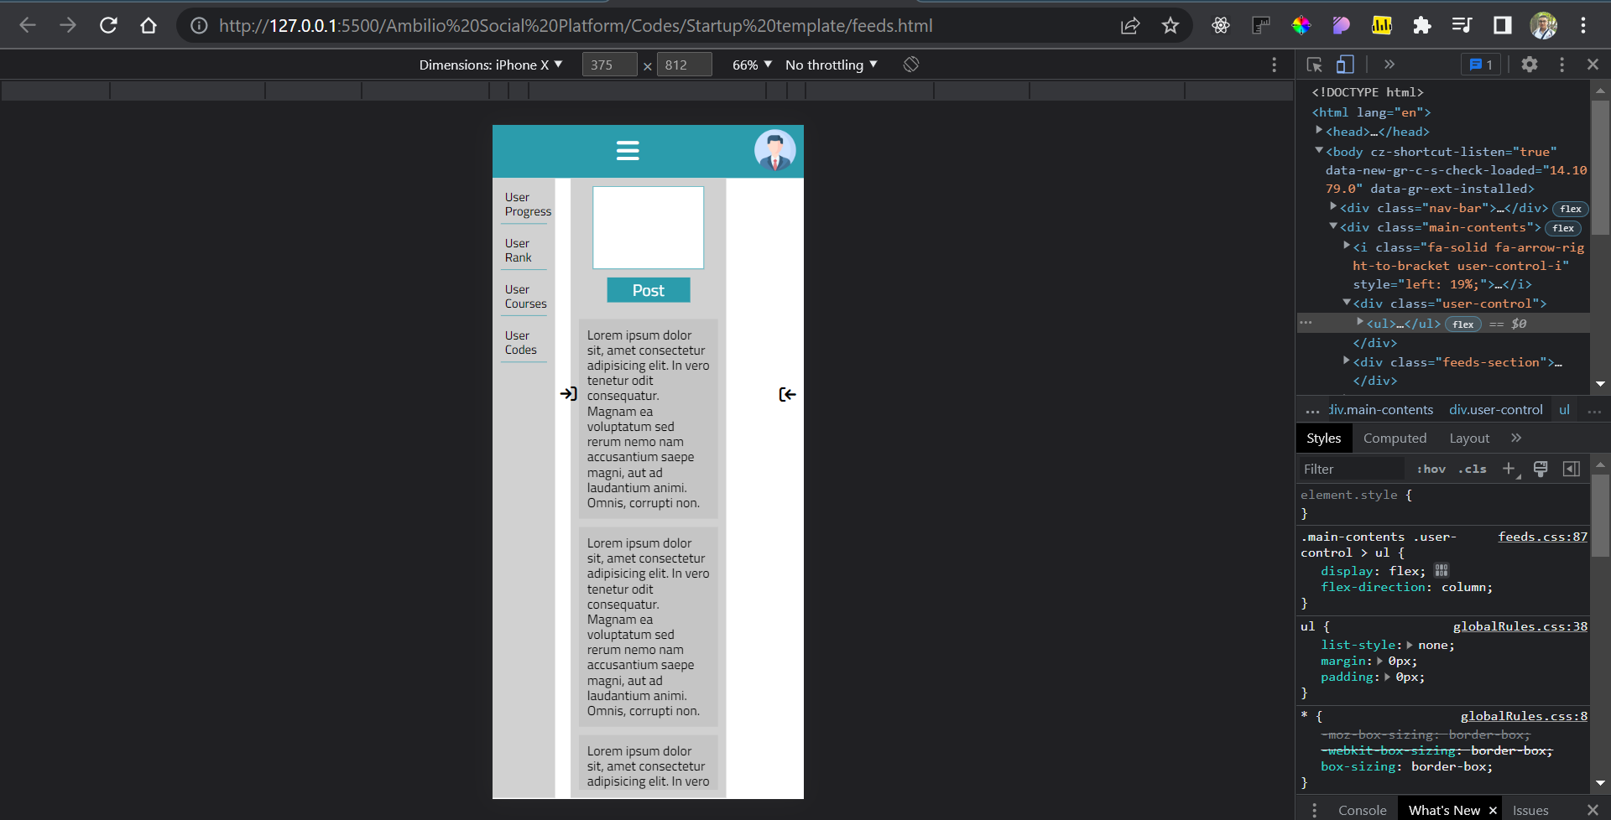

If the User control panel is not hidden :

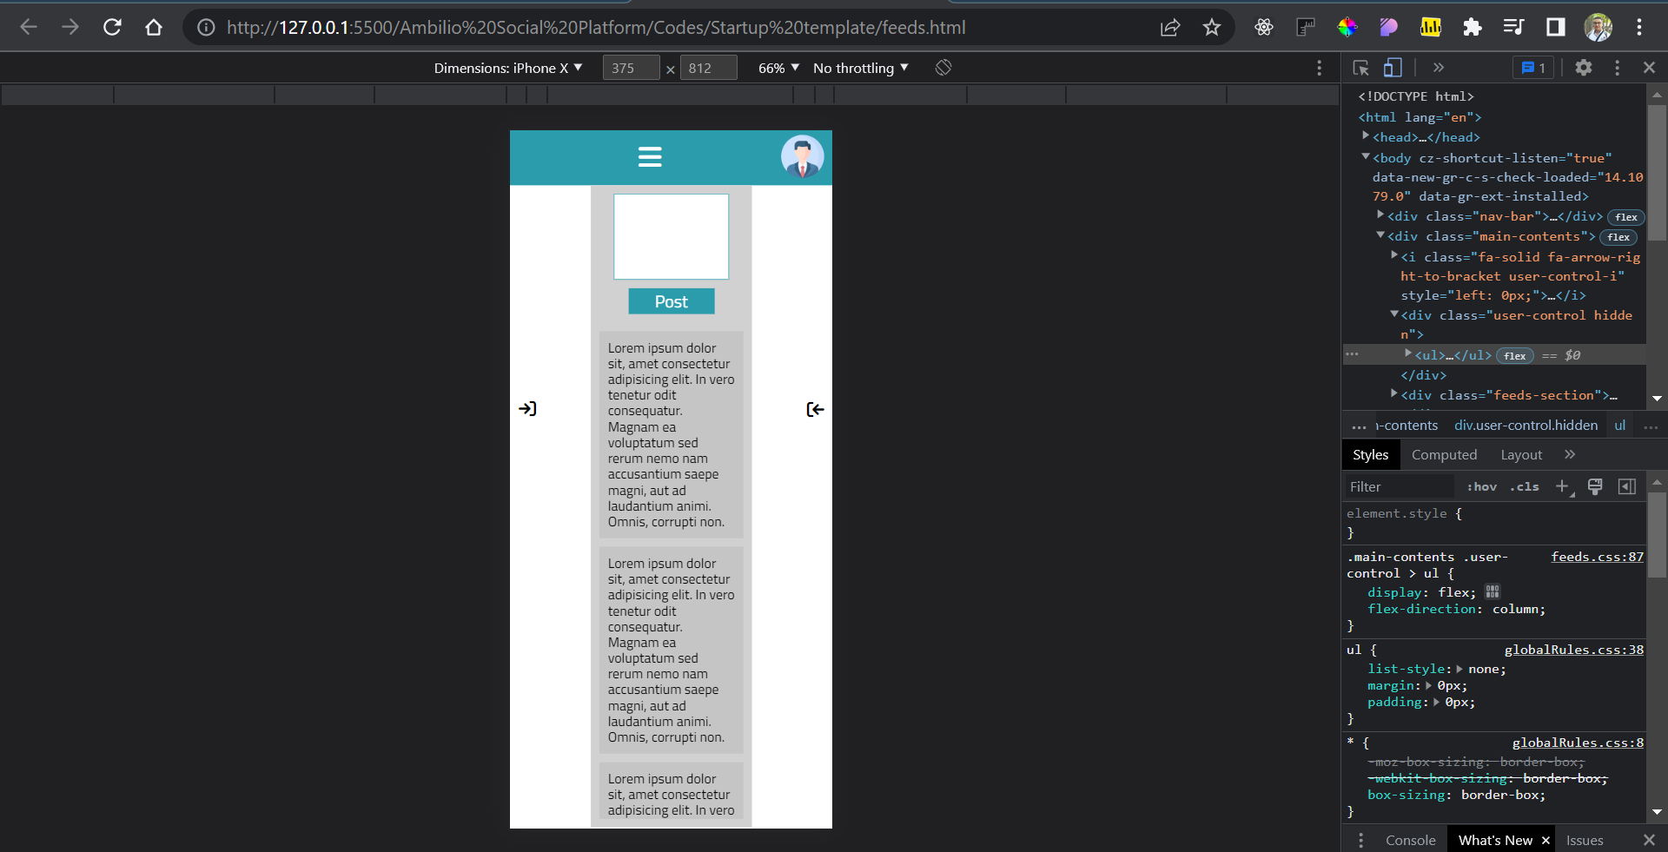

1. On click on the right arrow :

If the Recommended panel is hidden :

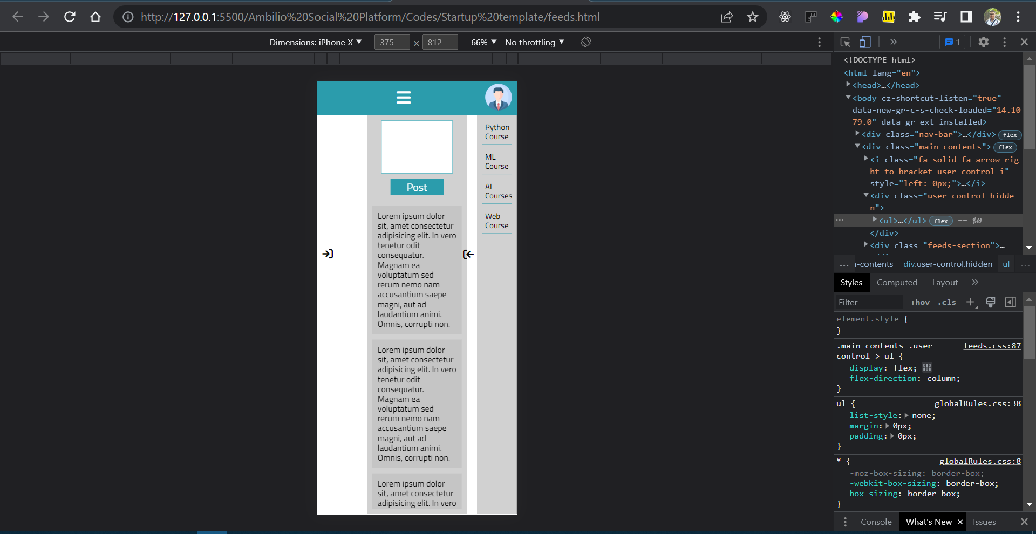

If the Recommended panel is not hidden :

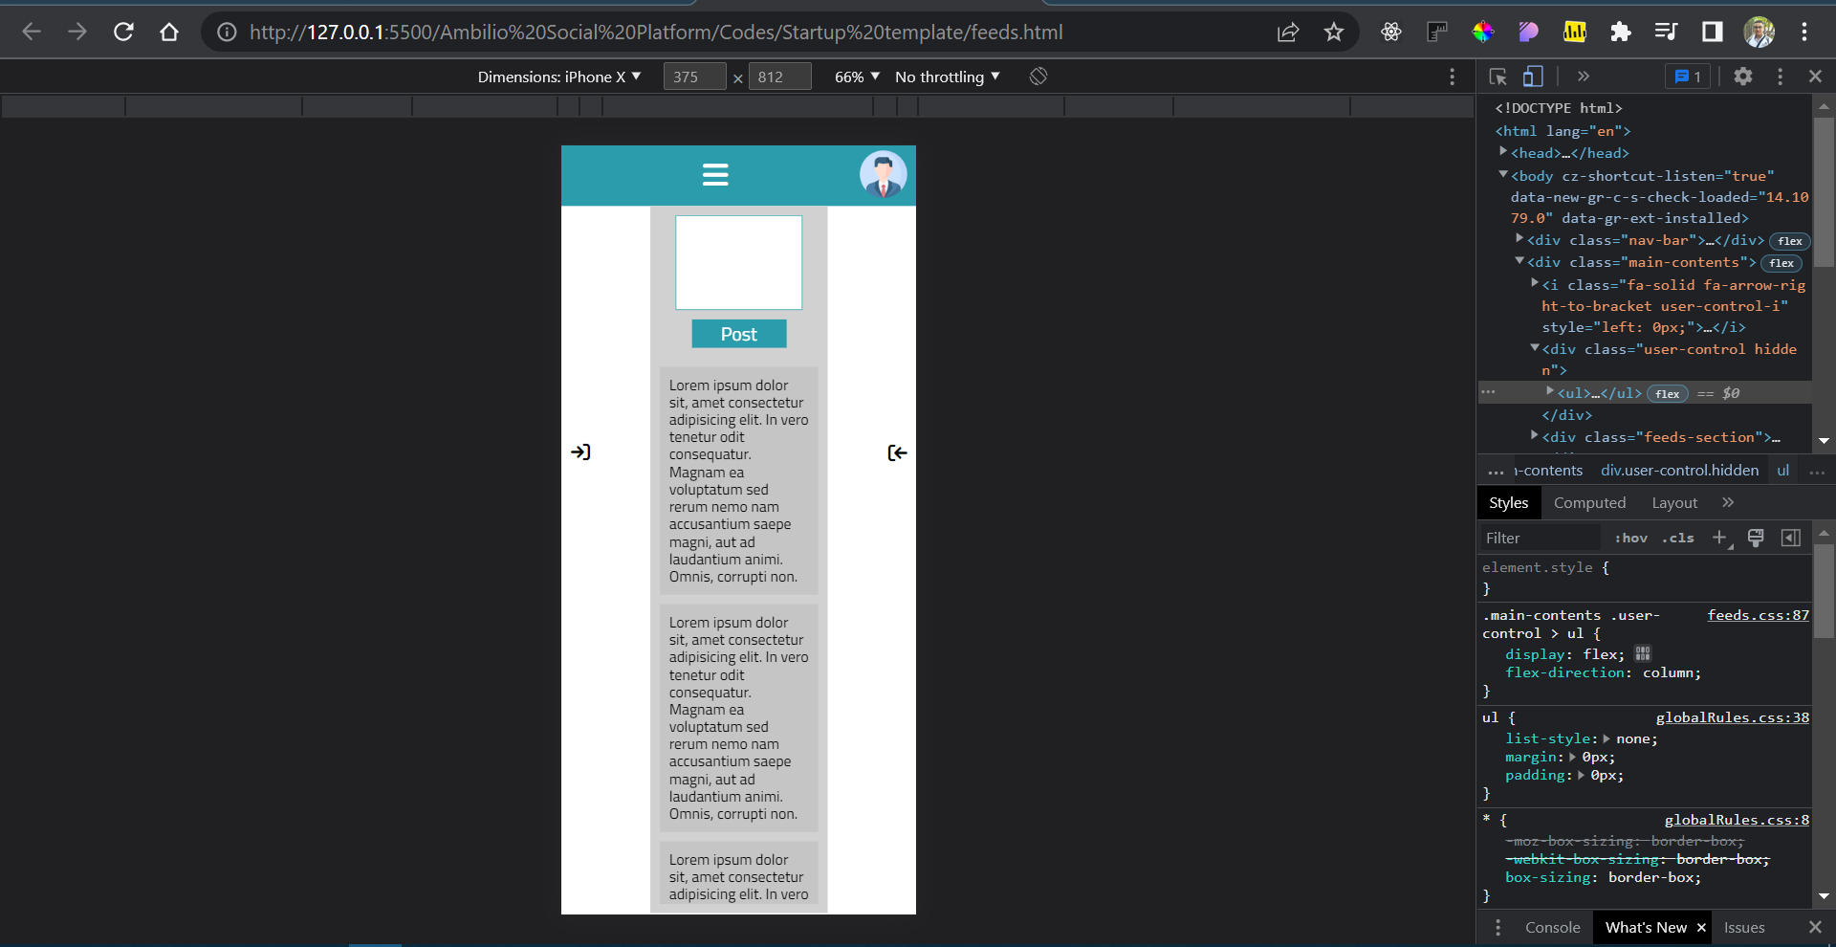

1. On click on the Nav-bar Icon :

If the nav-bar options are hidden :

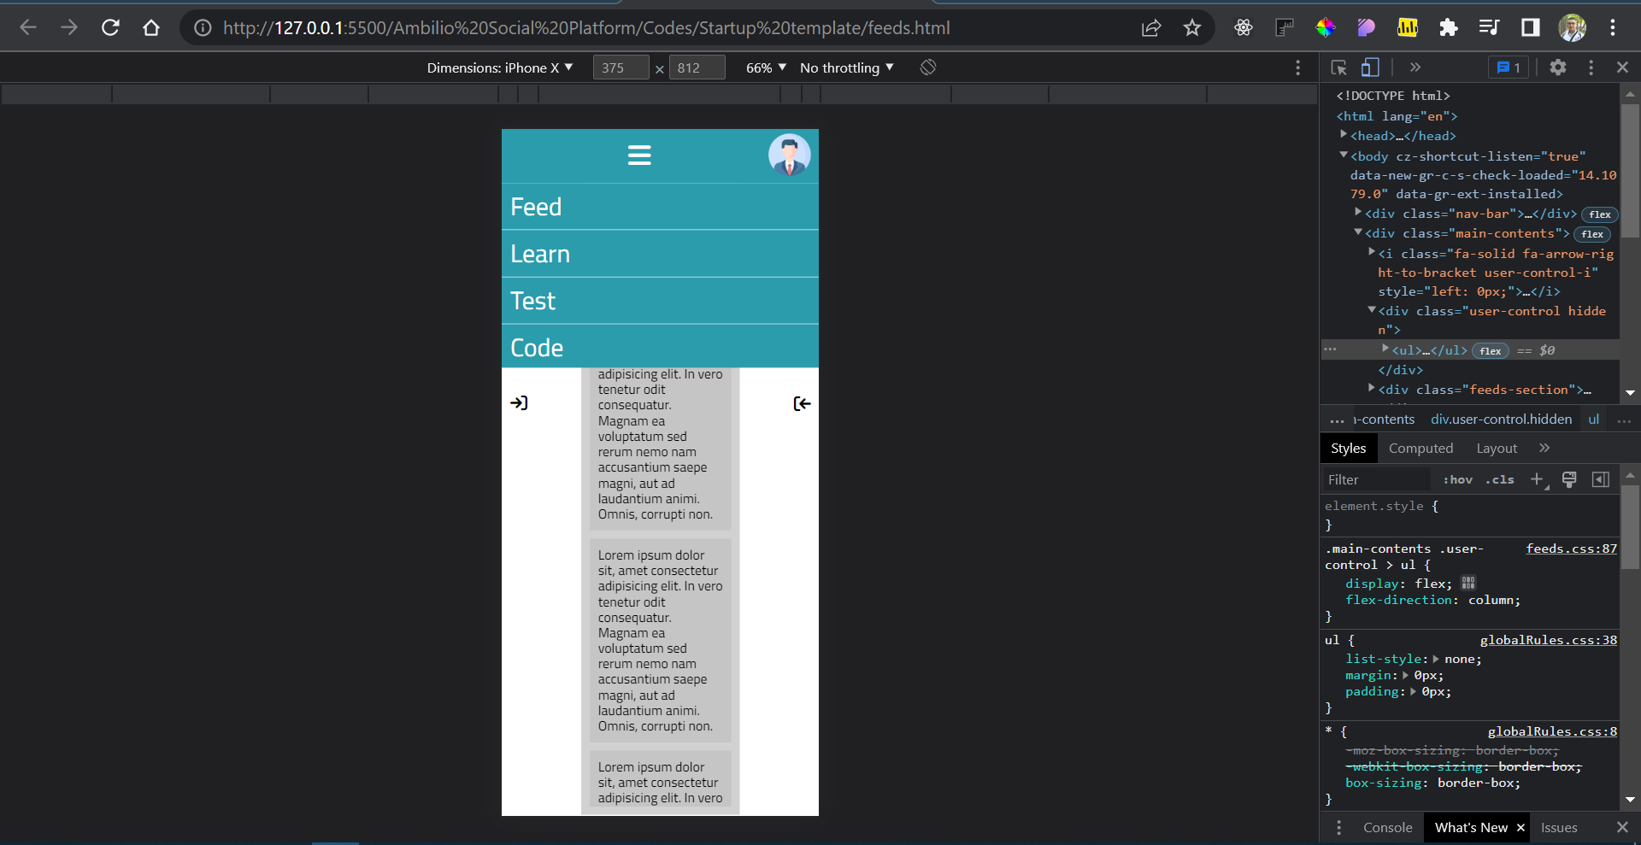

If the nav-bar options are not hidden :

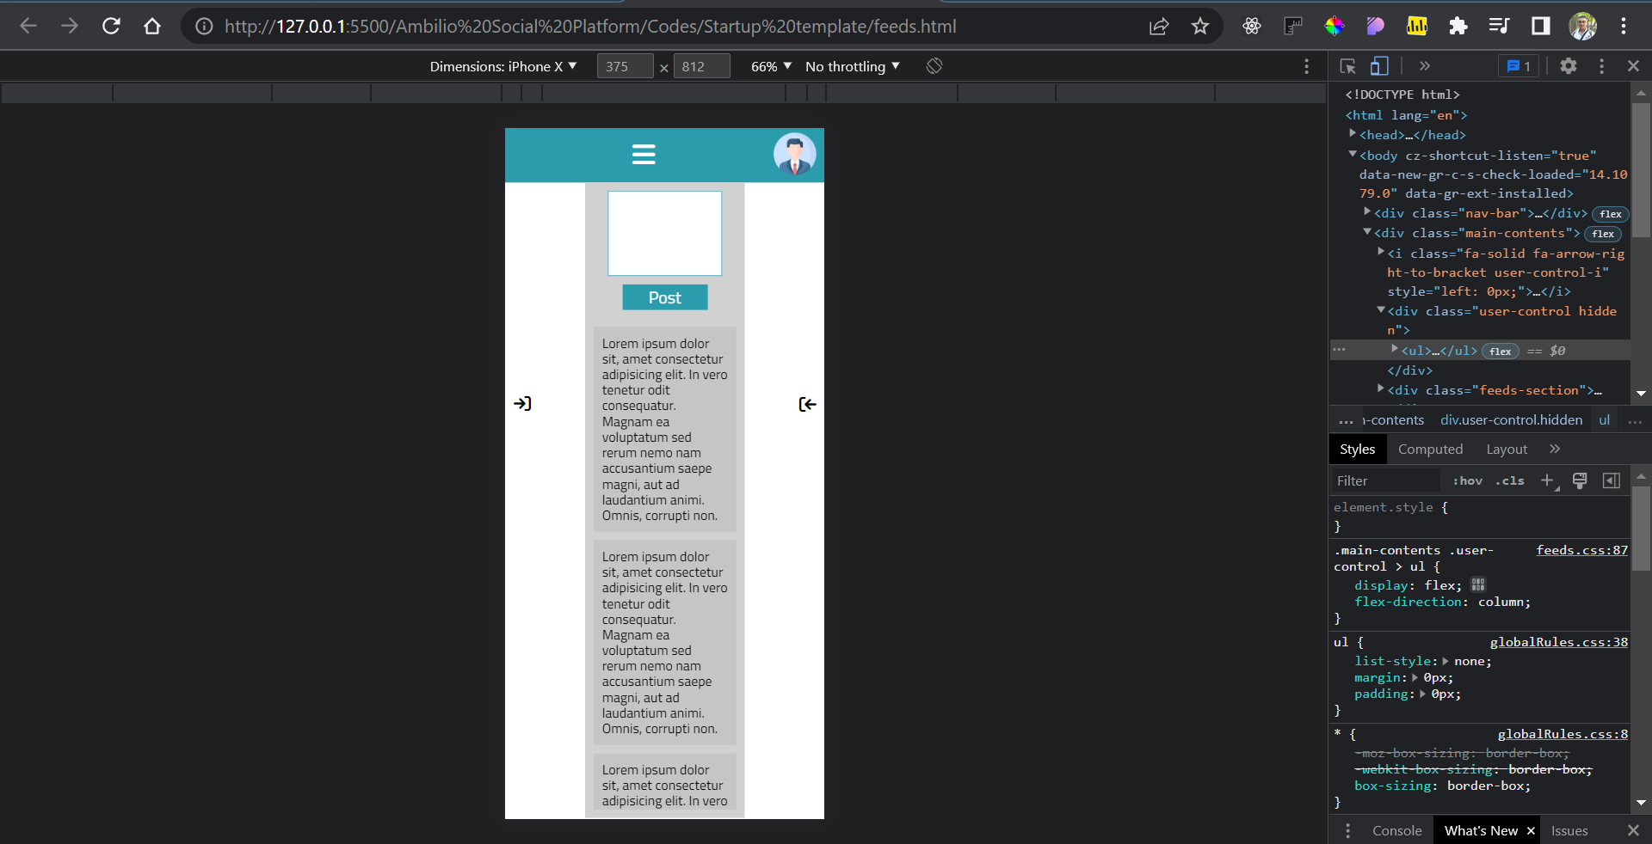

1-Note about feeds section : The post, author name, author avatar, Date of post …etc should came from the database (This is just a prototype and static UI to clarify how Feeds page should look like.)

2-Note about Recommended Items section : The recommended Items are the production of ML module which linked to the database (The Items which appears on this prototype UI is static just to clarify how Feeds page should look like.)

**Prototype sketch for feeds page :**

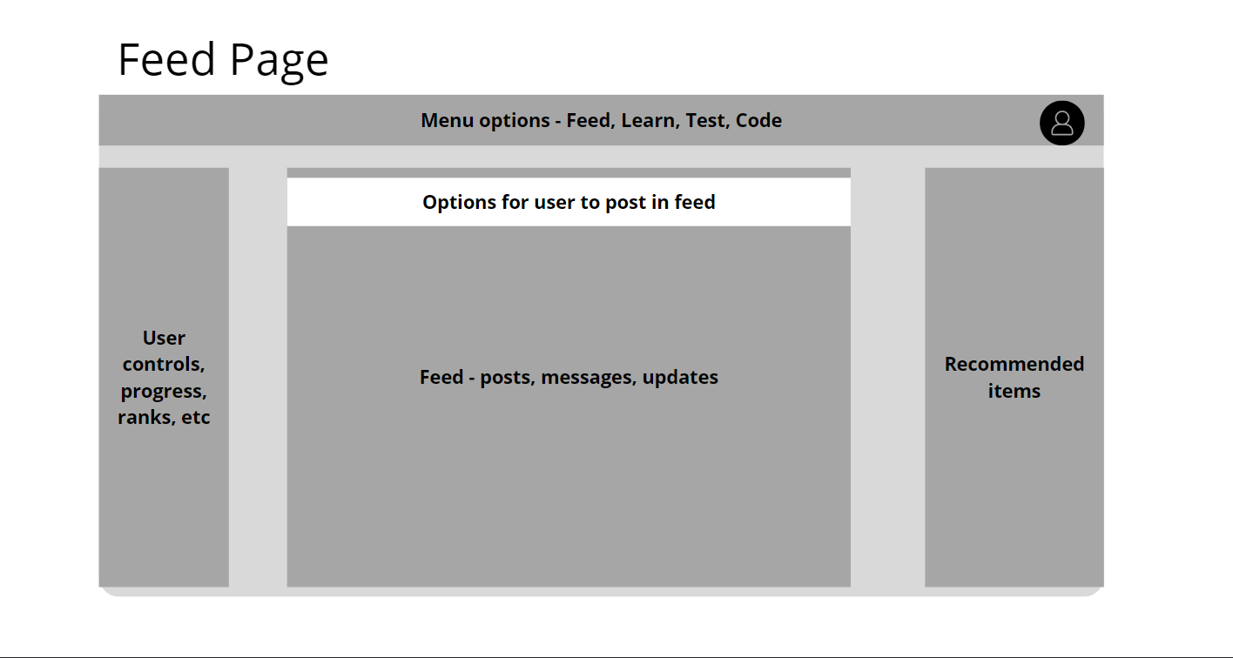

Should come from the database depending on user entered details

Should come from the database depending on user status

1. Profile Page :

Overview on large screens :

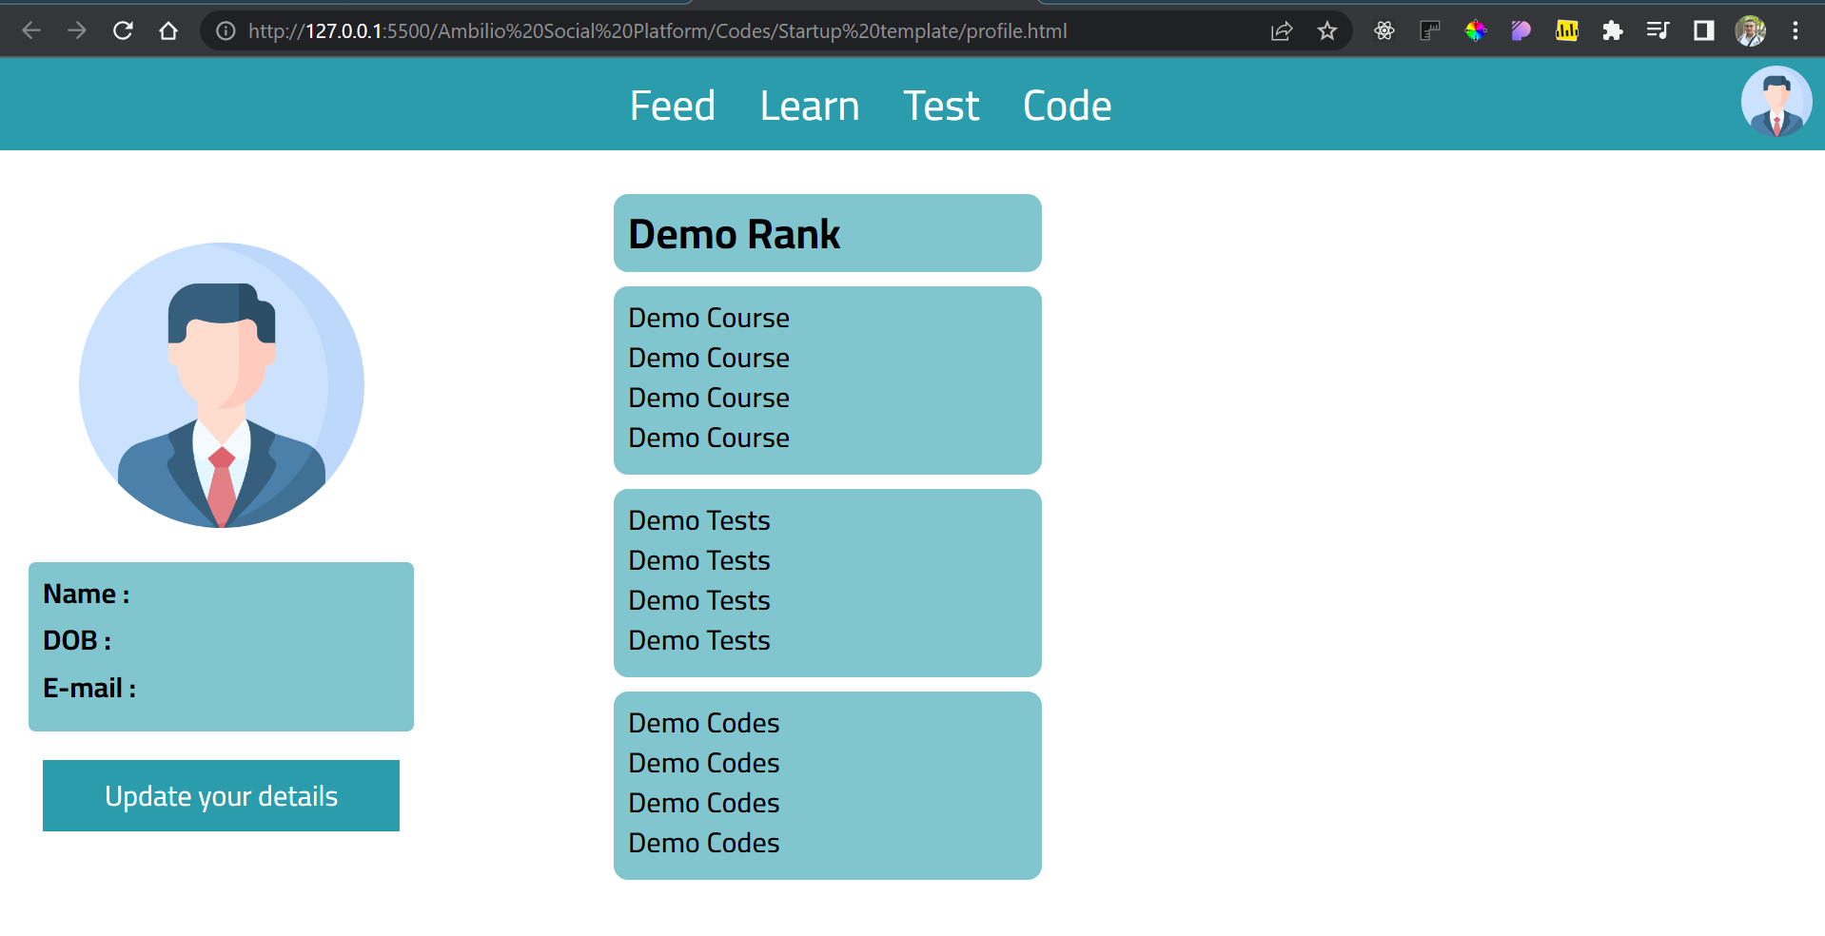

Overview on small screens :

For Example Iphone X :

1)

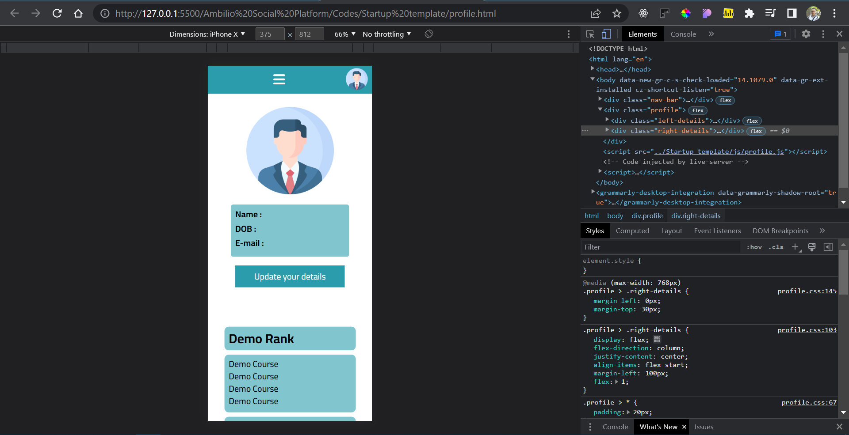

2)

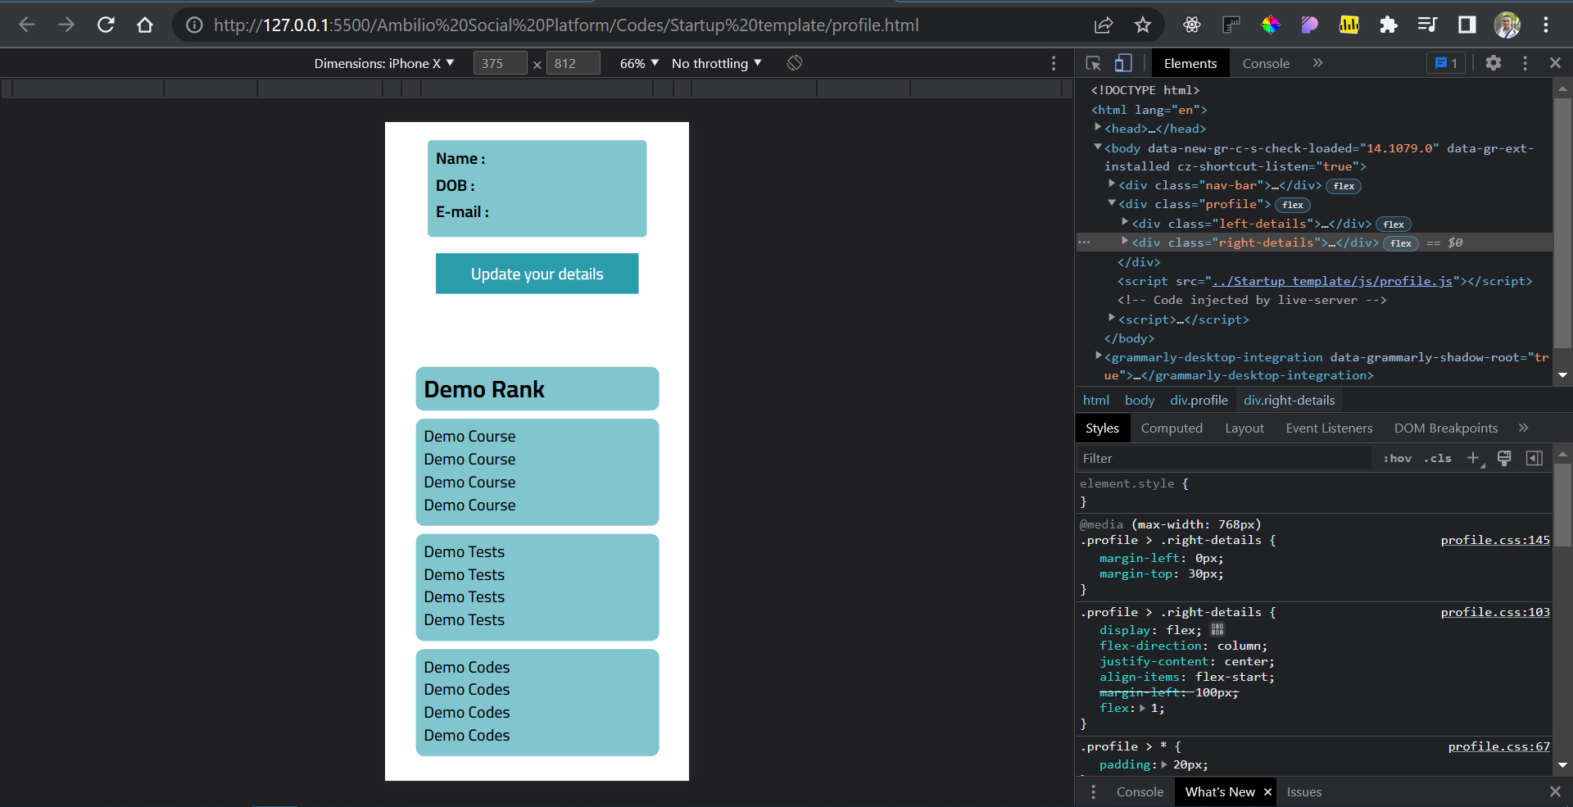

**New feature added during this development stage:**

1-Linked pages : Feed page ===> profile page :

On click on the profile photo in the top bar in feed page the browser will redirect the user to his profile page :

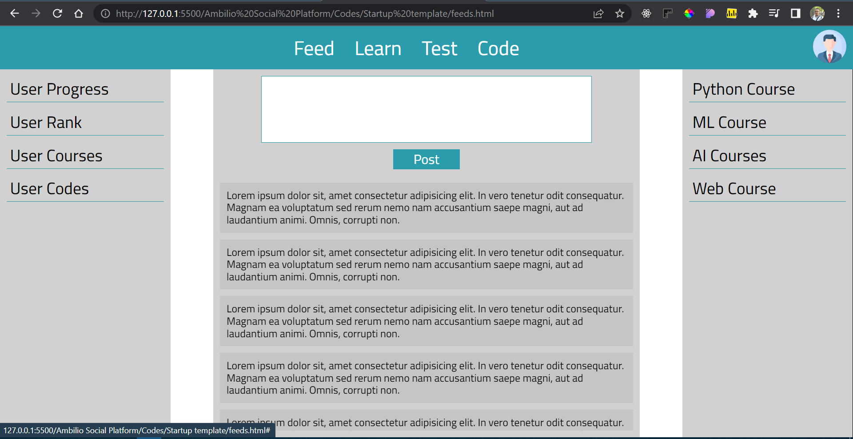

Redirecting to :

On click

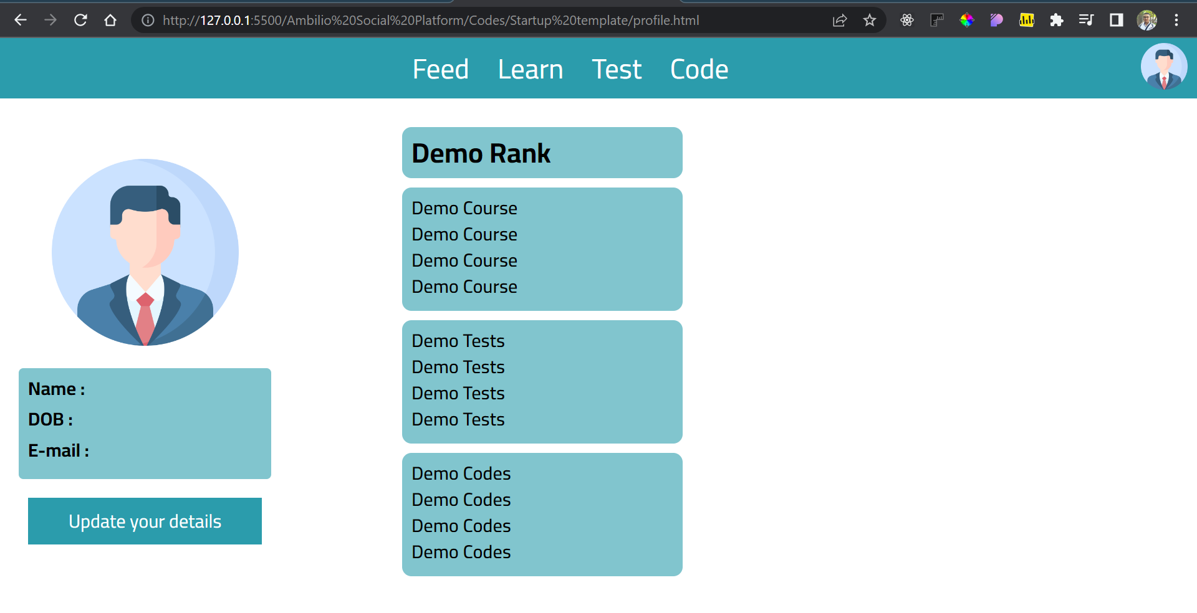

JavaScript functionality in profile page :

Only Nav-bar logic which every page in the website contain this logic since the Nav-bar component is a main component of user movement.

1. Note about profile page : The major details, User rank, Course taken, Codes taken …etc should came from the database (This is just a prototype and static UI to clarify how profile page should look like for the back-end developer.)

**Prototype sketch for profile page :**

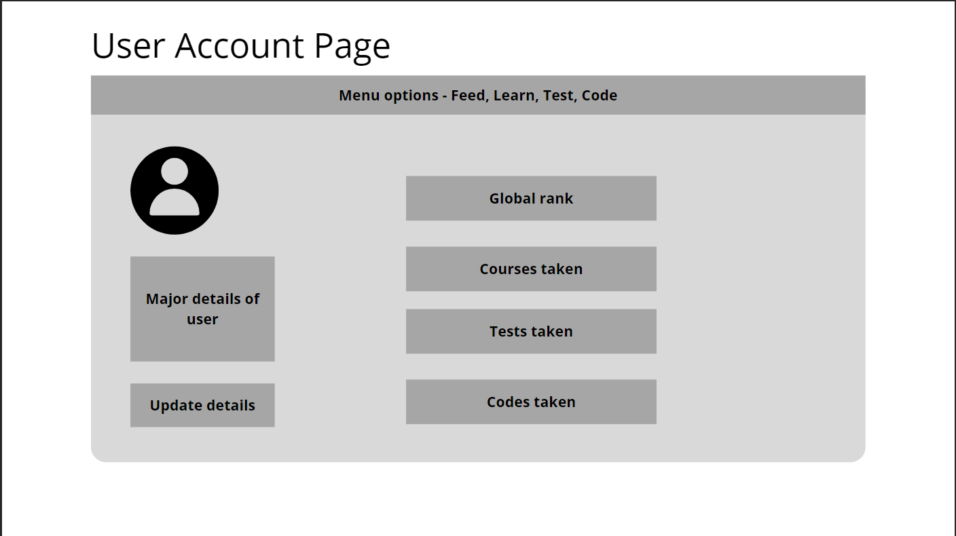

It will be better if I add *[thumbnail](https://www.google.com/search?sxsrf=ALiCzsb2PGOCc48gjVYePoTmFGTwDpO9xg:1665252705505&q=thumbnail&spell=1&sa=X&ved=2ahUKEwjF6-PfndH6AhXD7DgGHTJgAKIQkeECKAB6BAgHEAE)*s and title for the cards instead of the gray background and “Catalogue of courses” title, it will increase the UX rate, so I build it as the sketch instructions till we meet and discuss.

1. Learn page :

Overview on large screens :

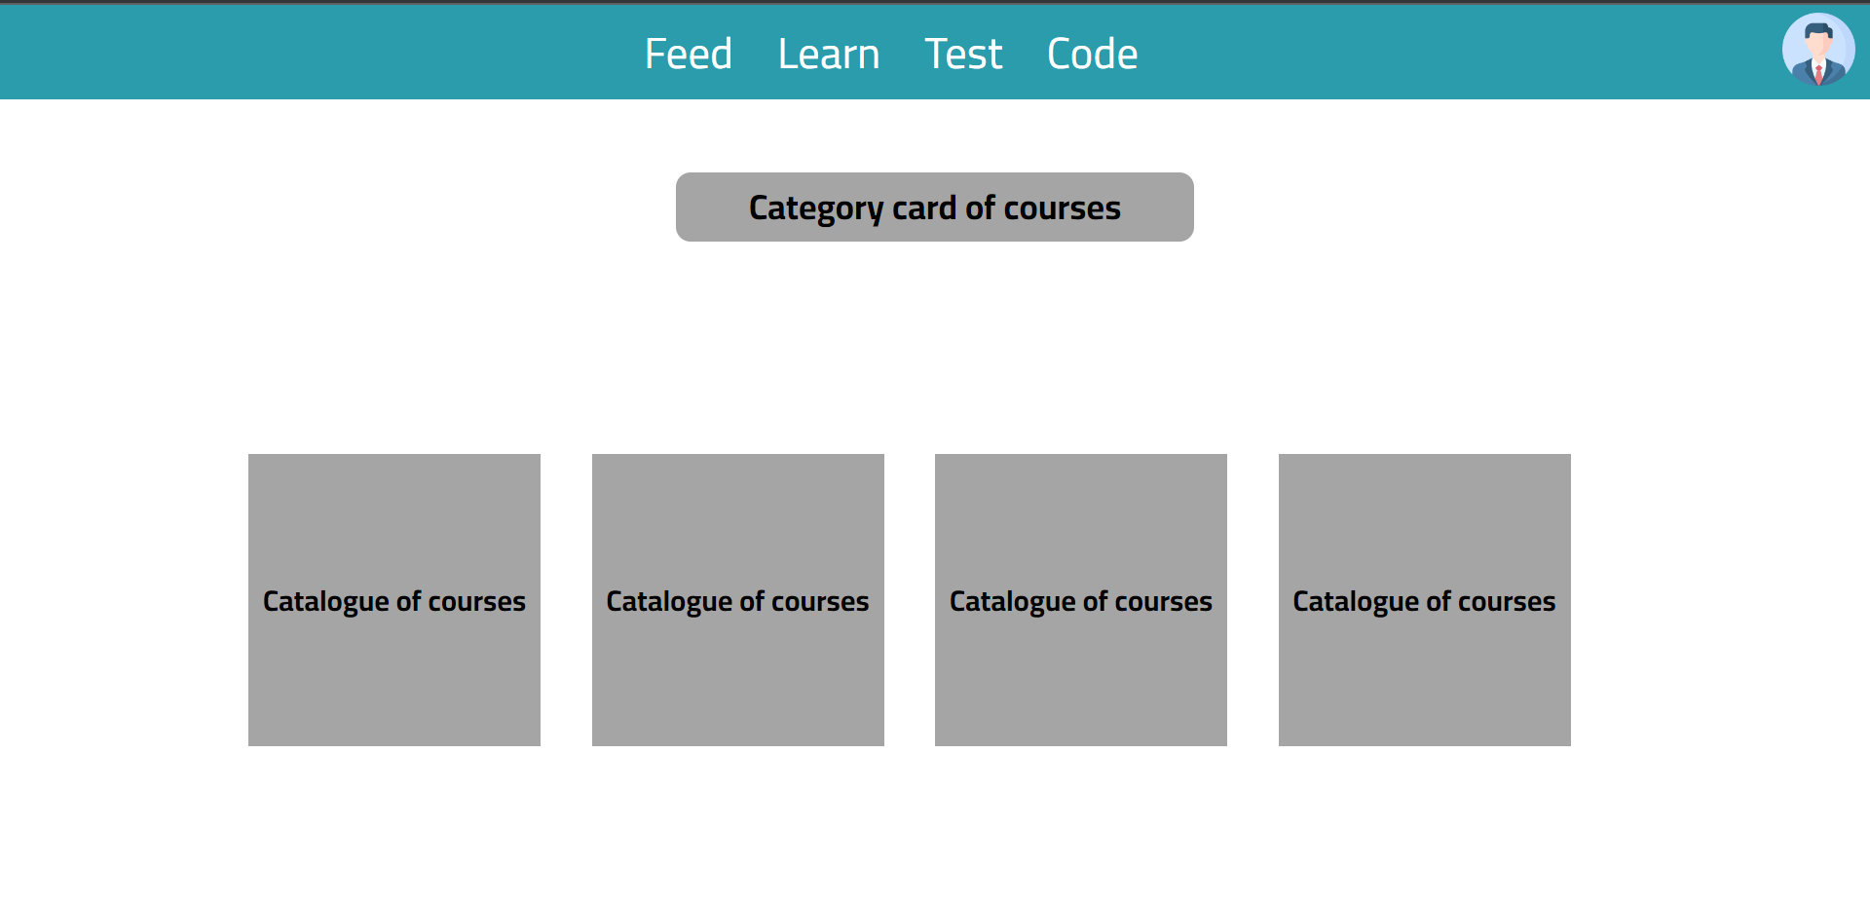

Overview on small screens :

For Example Iphone X :

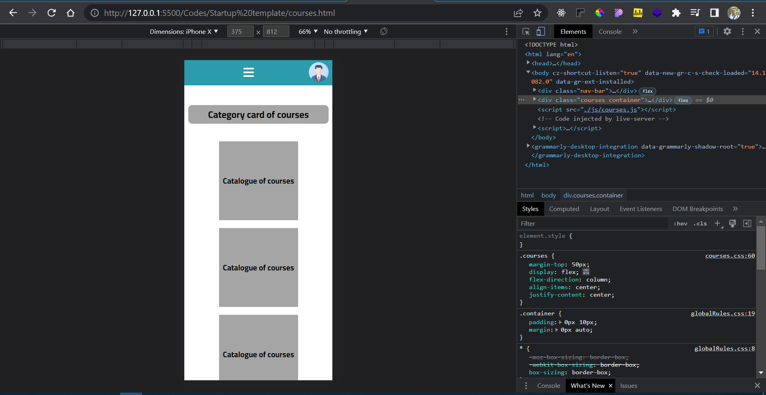

**Prototype sketch for learn page :**

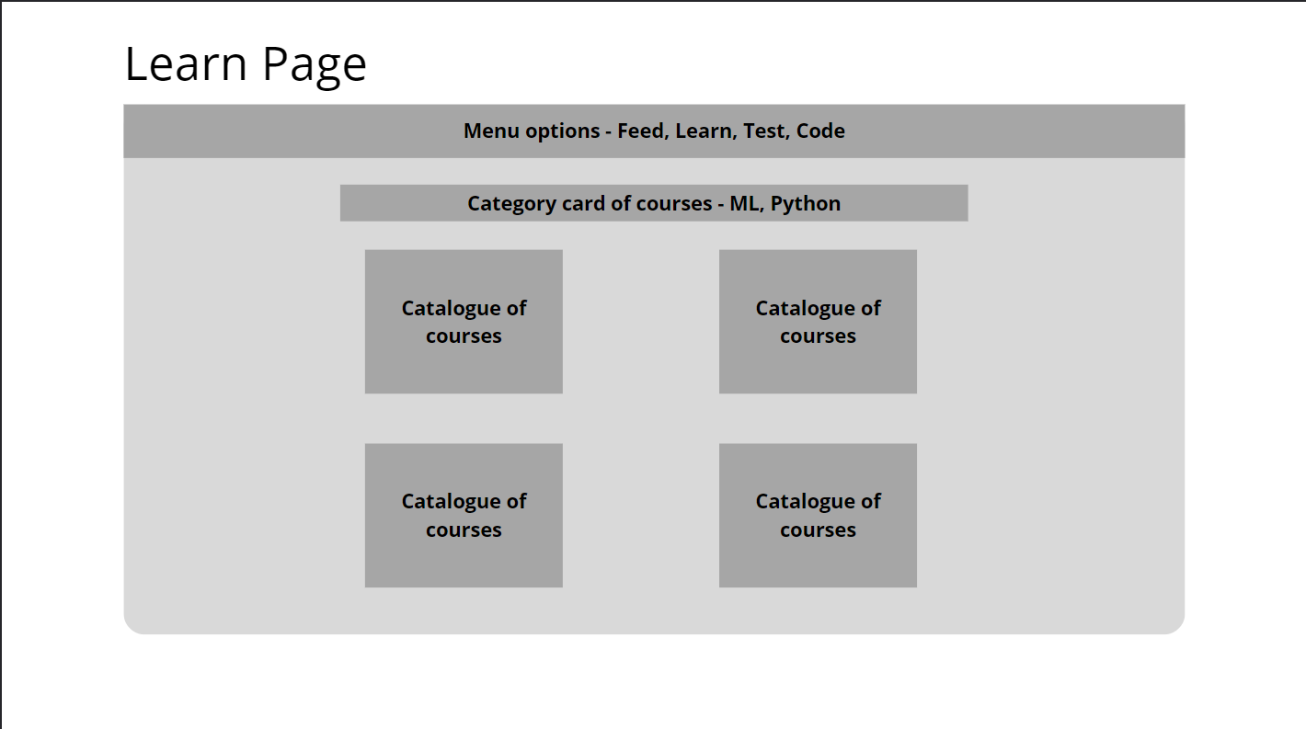

1. Codes page :

It will be better if I add *[thumbnail](https://www.google.com/search?sxsrf=ALiCzsb2PGOCc48gjVYePoTmFGTwDpO9xg:1665252705505&q=thumbnail&spell=1&sa=X&ved=2ahUKEwjF6-PfndH6AhXD7DgGHTJgAKIQkeECKAB6BAgHEAE)*s and title for the cards instead of the gray background and “Catalogue of codes” title, it will increase the UX rate, so I build it as the sketch instructions till we meet and discuss.

Overview on large screens :

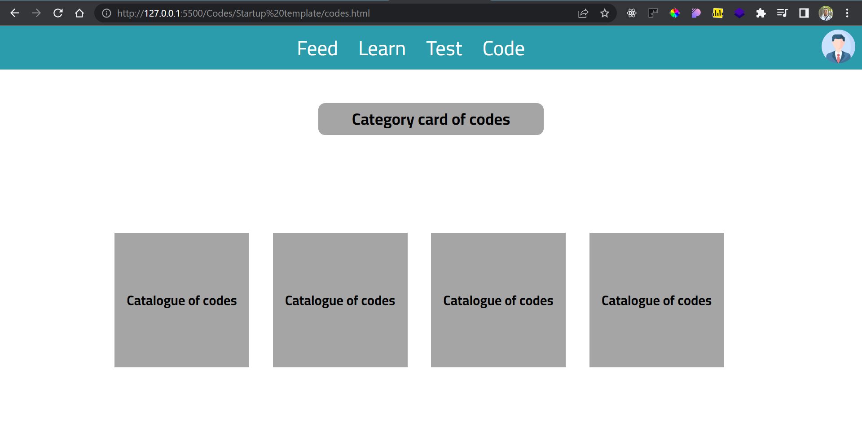

Overview on small screens :

For Example Iphone X :

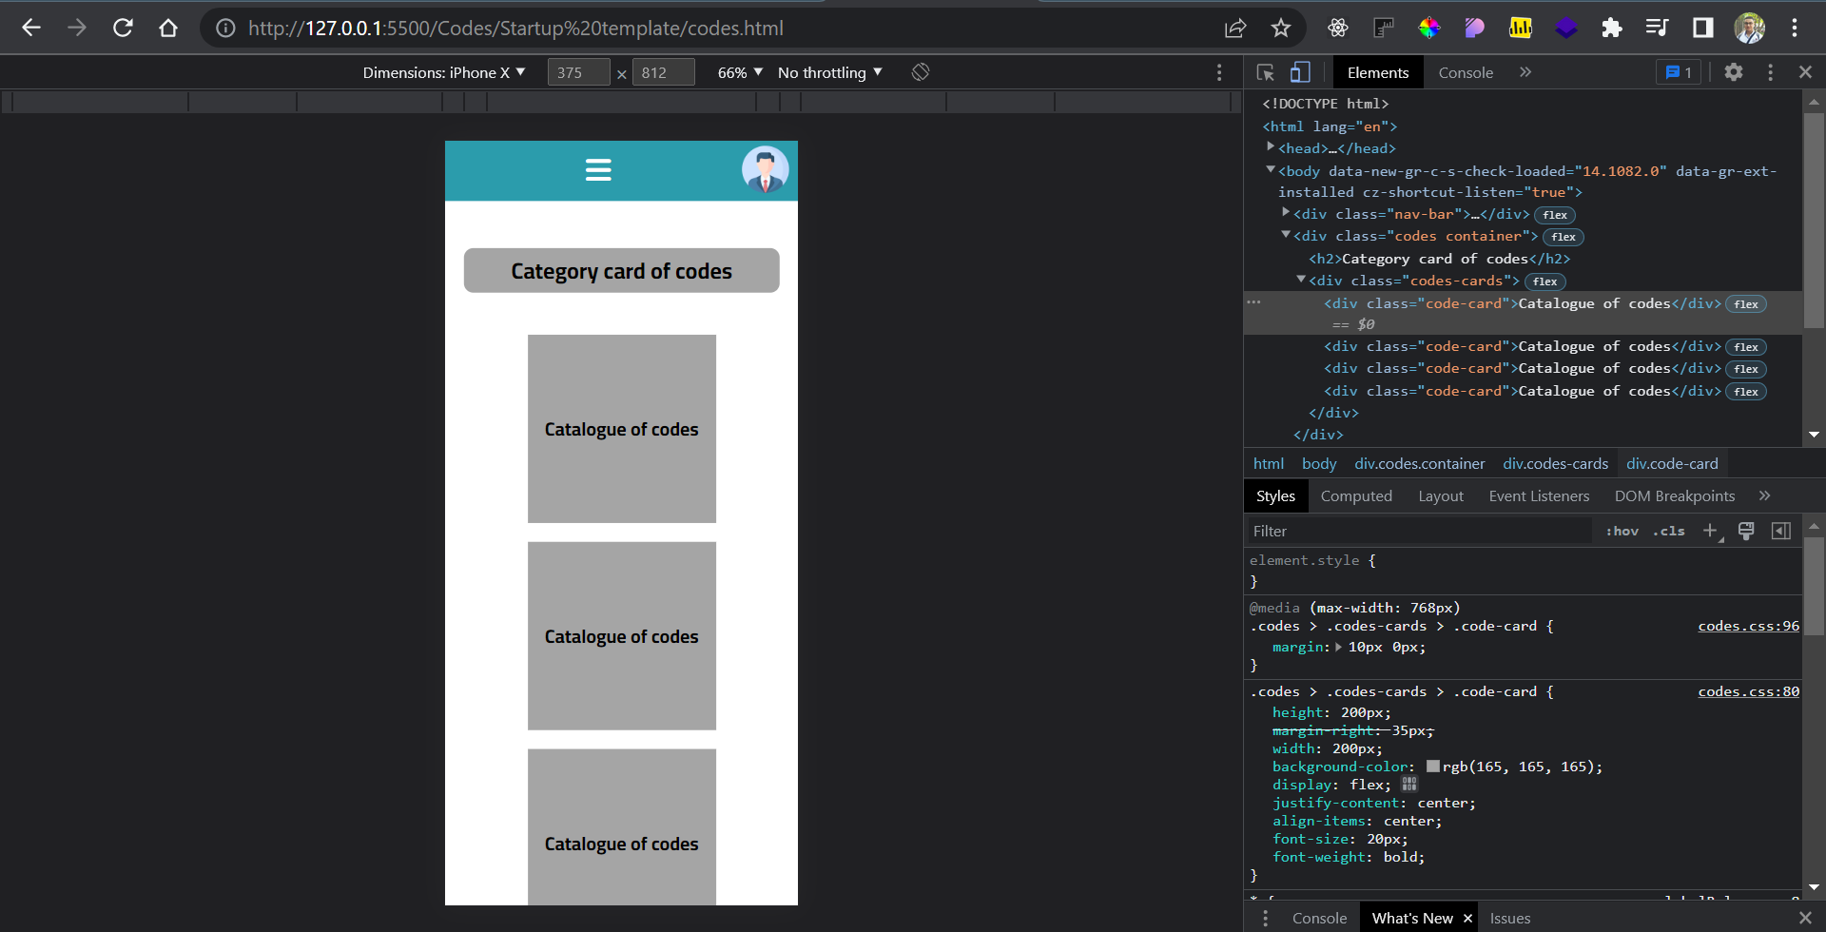

**Prototype sketch for codes page :**

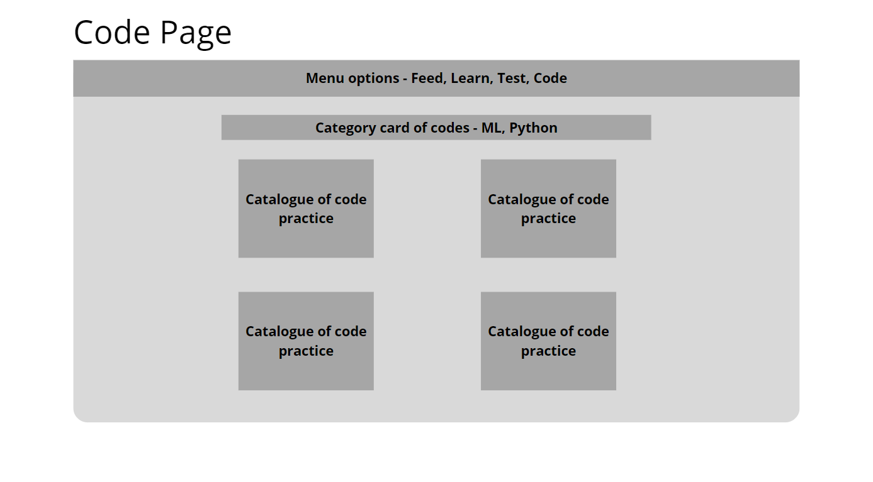

It will be better if I add *[thumbnail](https://www.google.com/search?sxsrf=ALiCzsb2PGOCc48gjVYePoTmFGTwDpO9xg:1665252705505&q=thumbnail&spell=1&sa=X&ved=2ahUKEwjF6-PfndH6AhXD7DgGHTJgAKIQkeECKAB6BAgHEAE)*s and title for the cards instead of the gray background and “Catalogue of tests” title, it will increase the UX rate, so I build it as the sketch instructions till we meet and discuss.

1. Tests page :

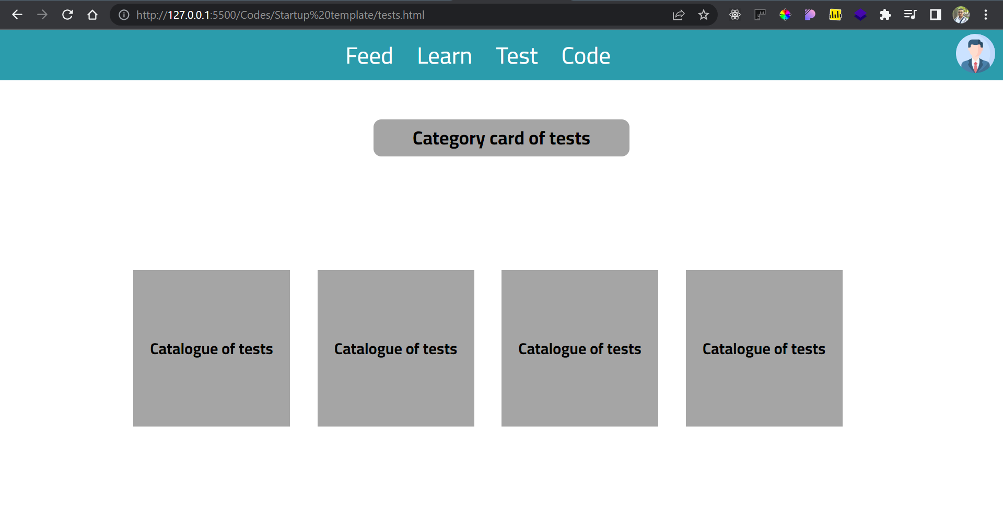

Overview on small screens :

For Example Iphone X

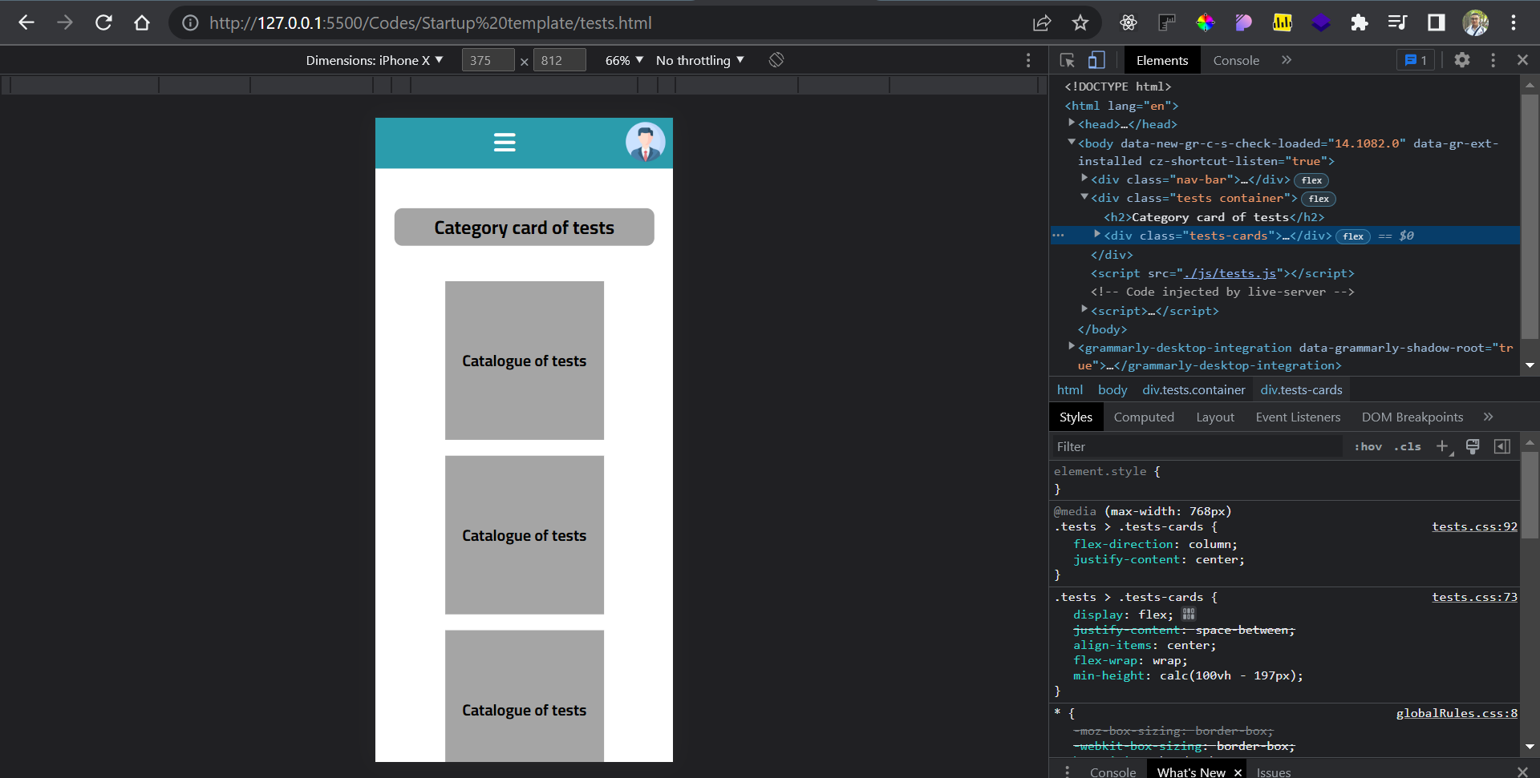

**Prototype sketch for tests page :**

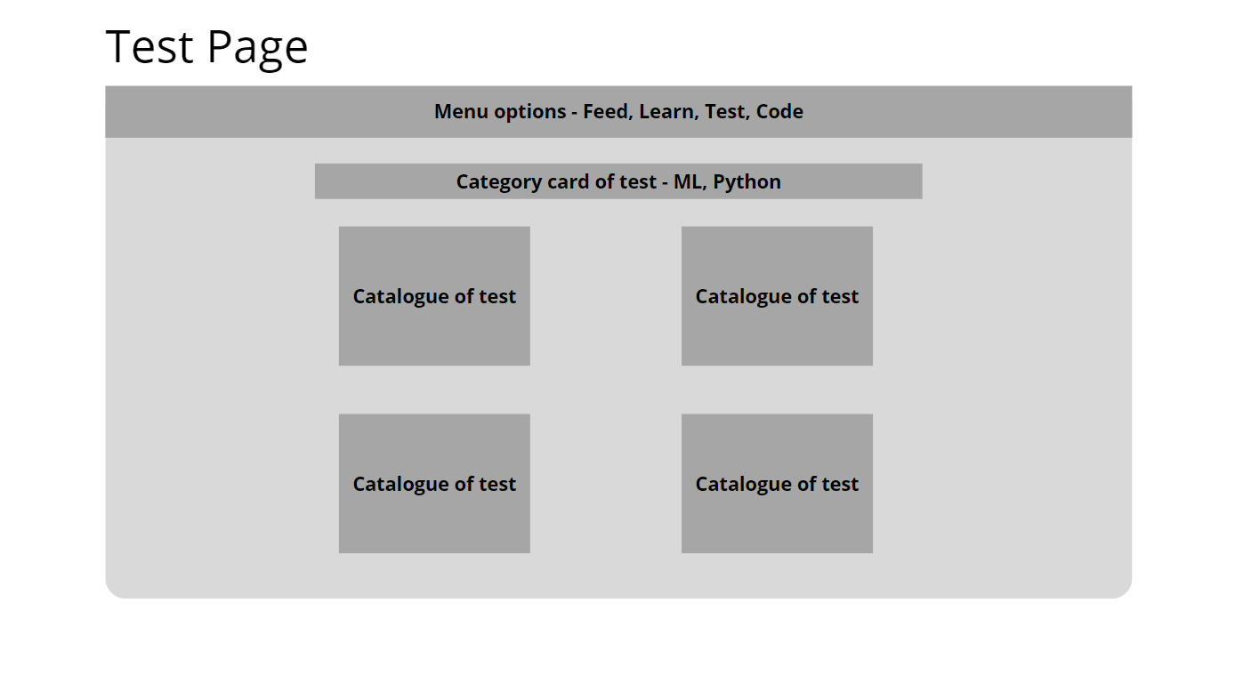

**New feature added during this development stage:**

1. All links in the Nav-bar are working now!  
    Its clickable now to redirect the user to the requested Page

**Example**

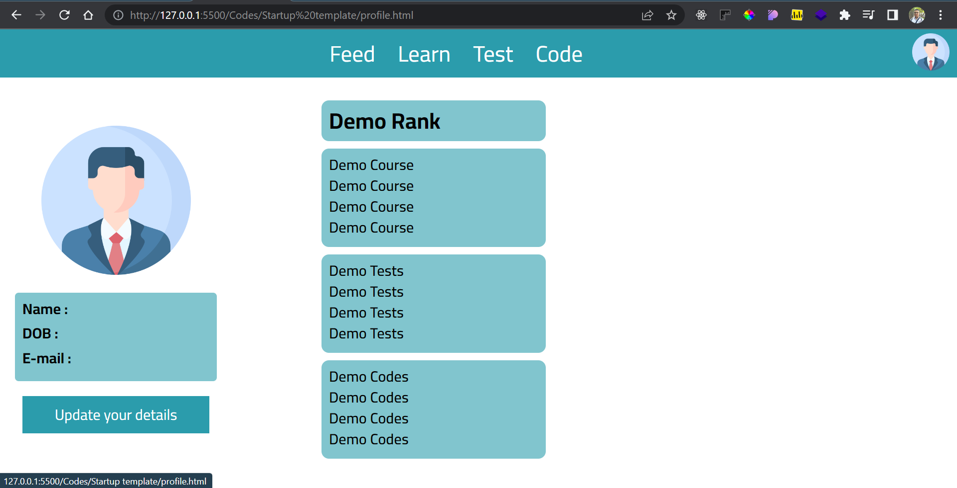

Redirecting

On click

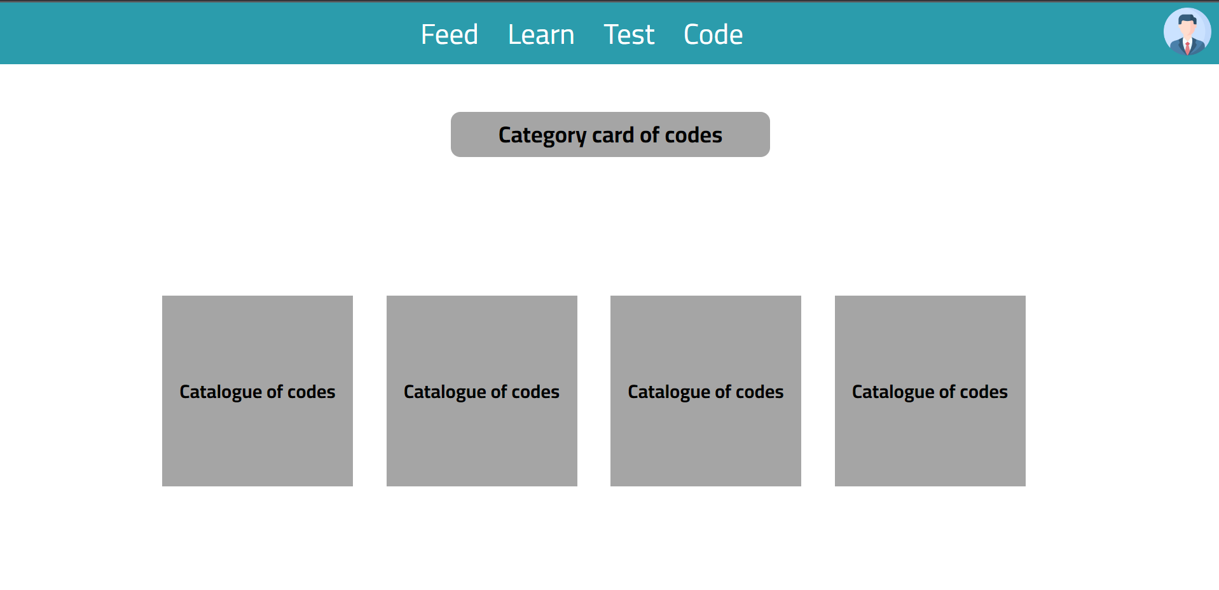

To the requested page

JavaScript functionality in Learn,Codes and Tests pages :

Only Nav-bar logic which every page in the website contain this logic since the Nav-bar component is a main component of user movement.

**Light house extension report :**

**1-Log-in page :**

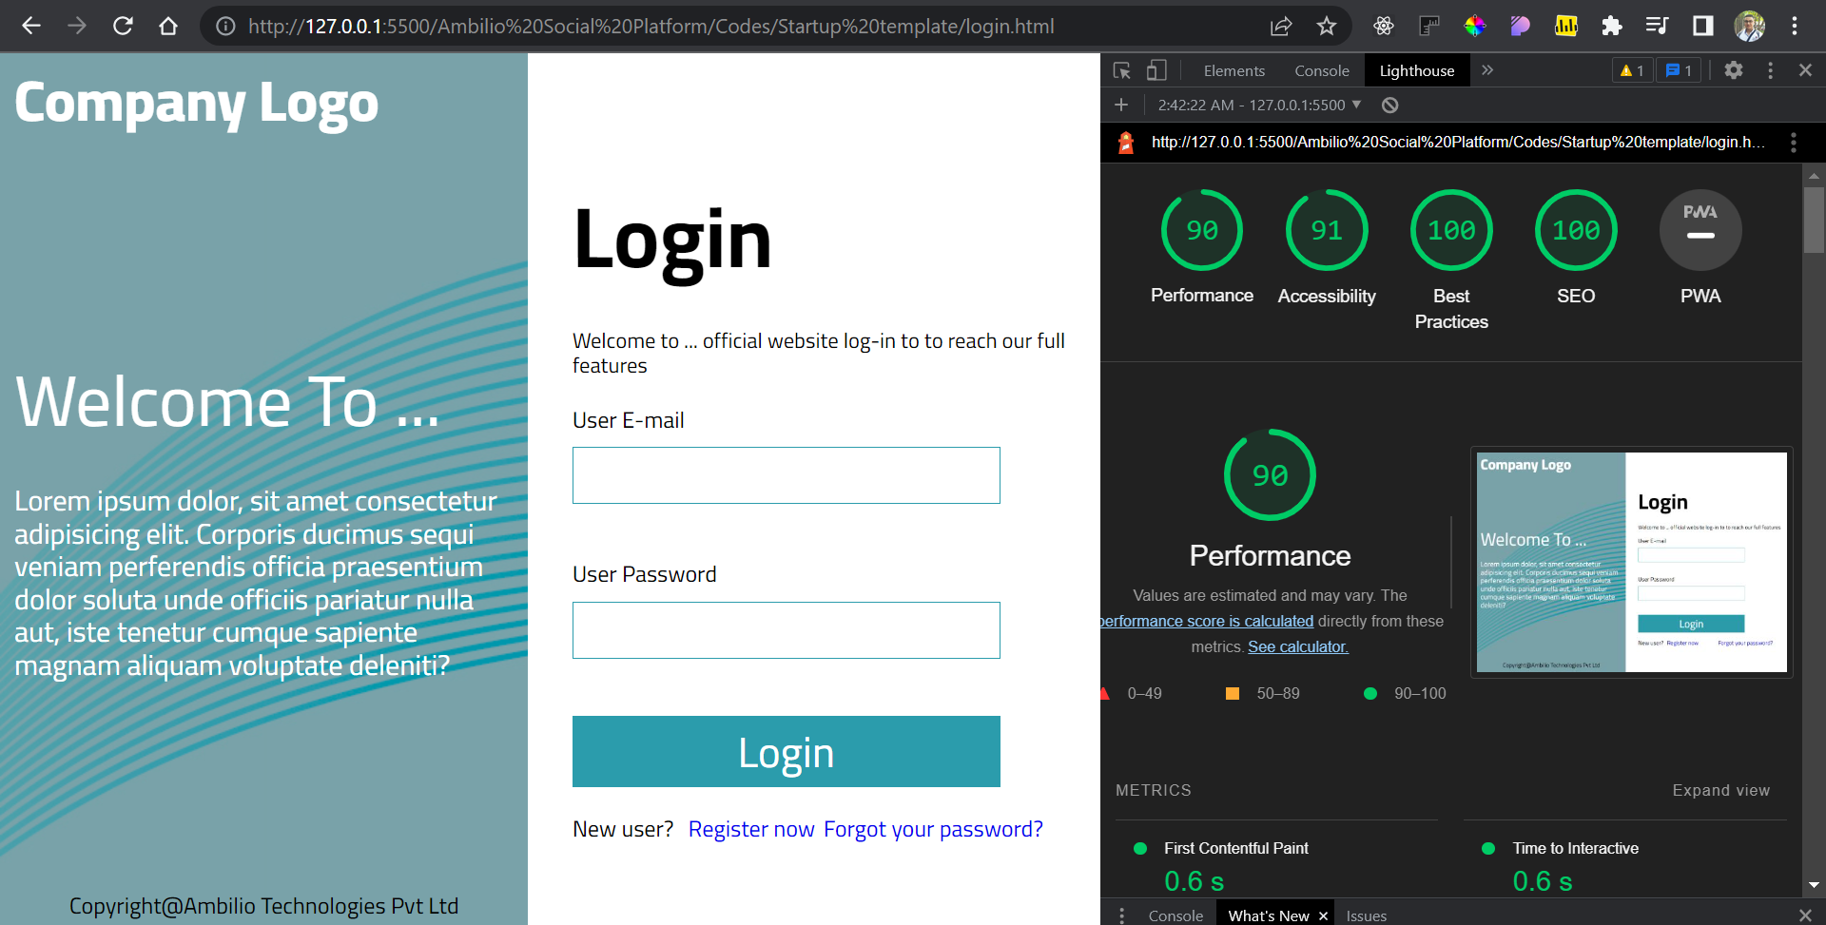

1. **Sign-up page :**

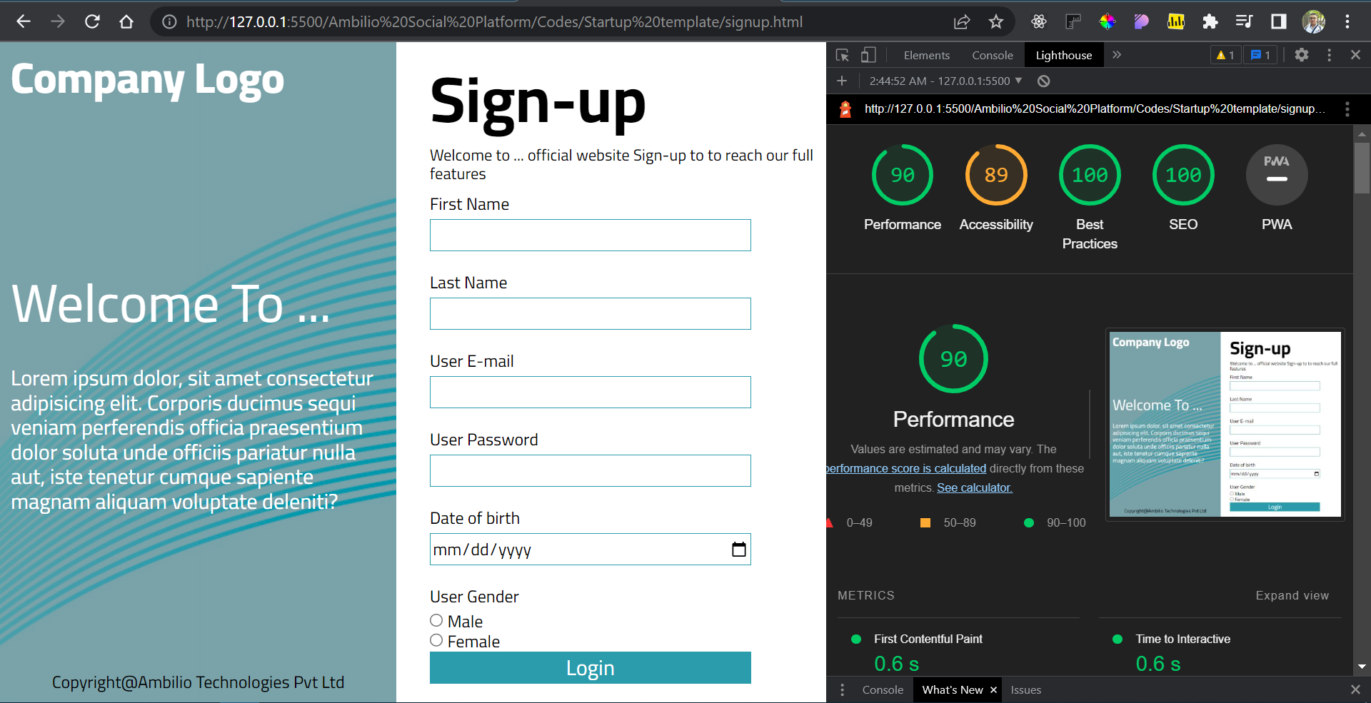

1. **Feeds page :**

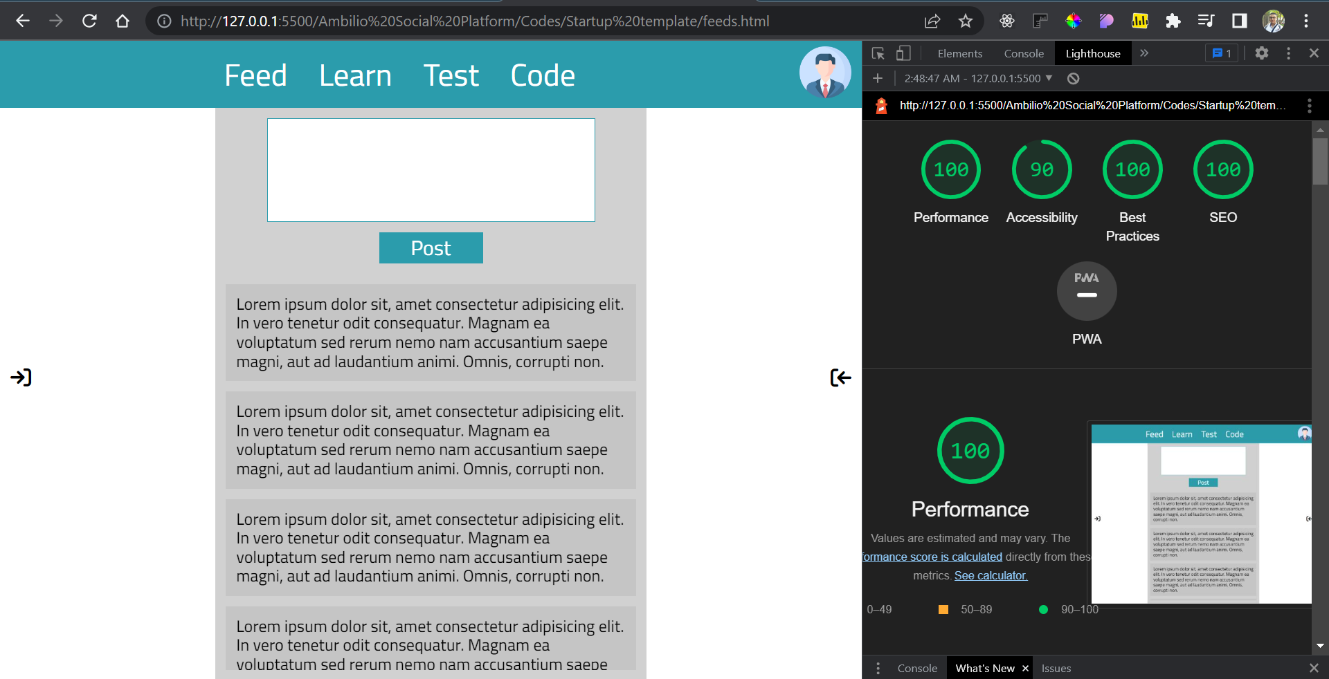

1. **Profile page :**

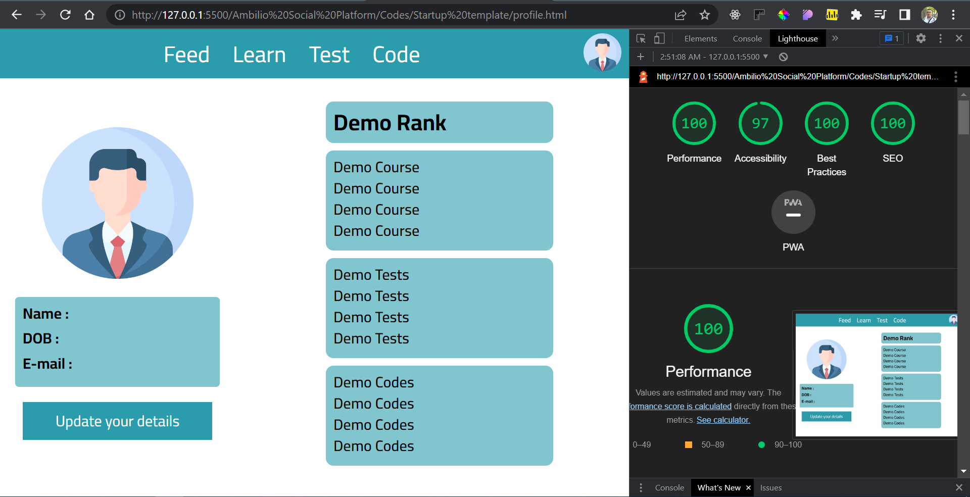

1. **Learn page :**

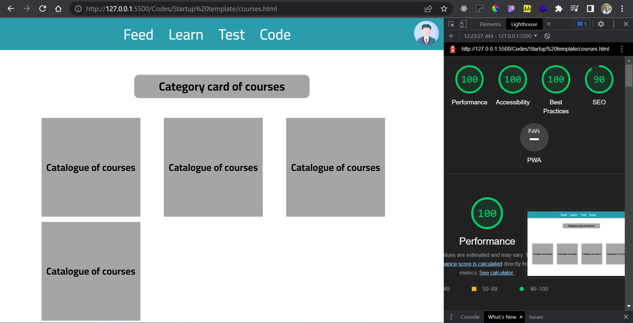

1. **Tests page :**

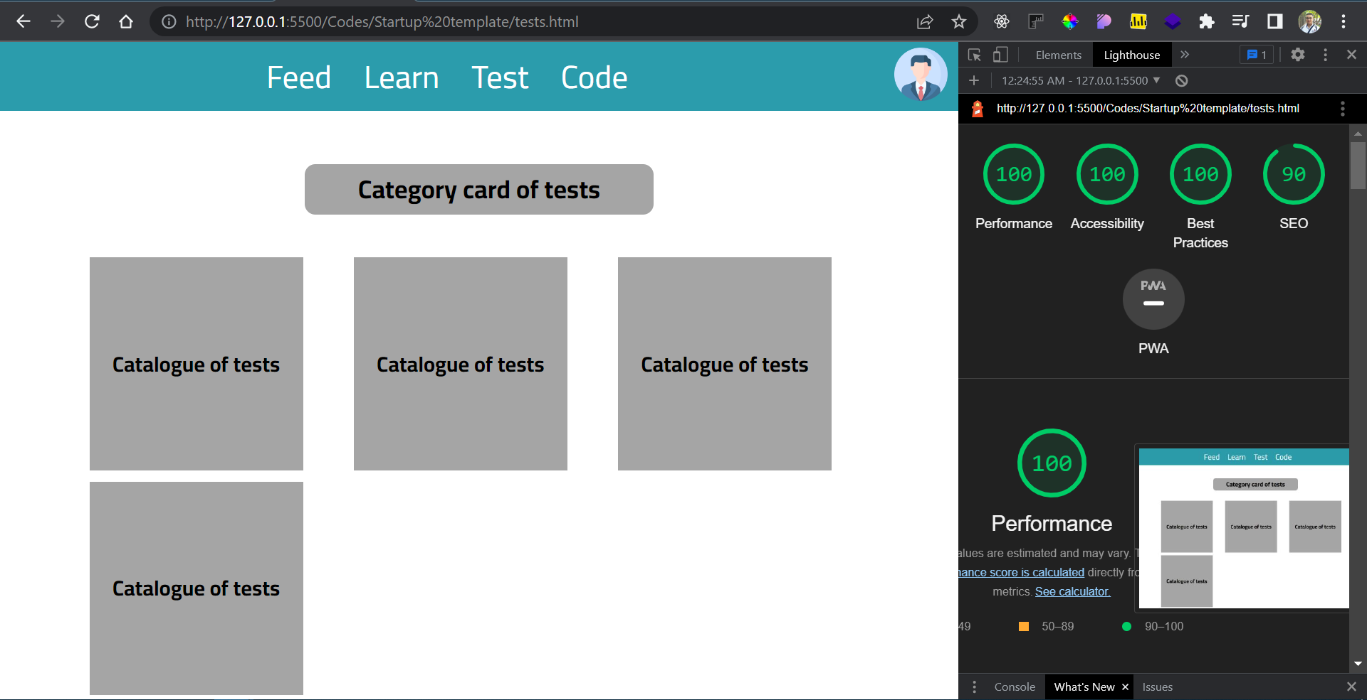

1. **Code page :**

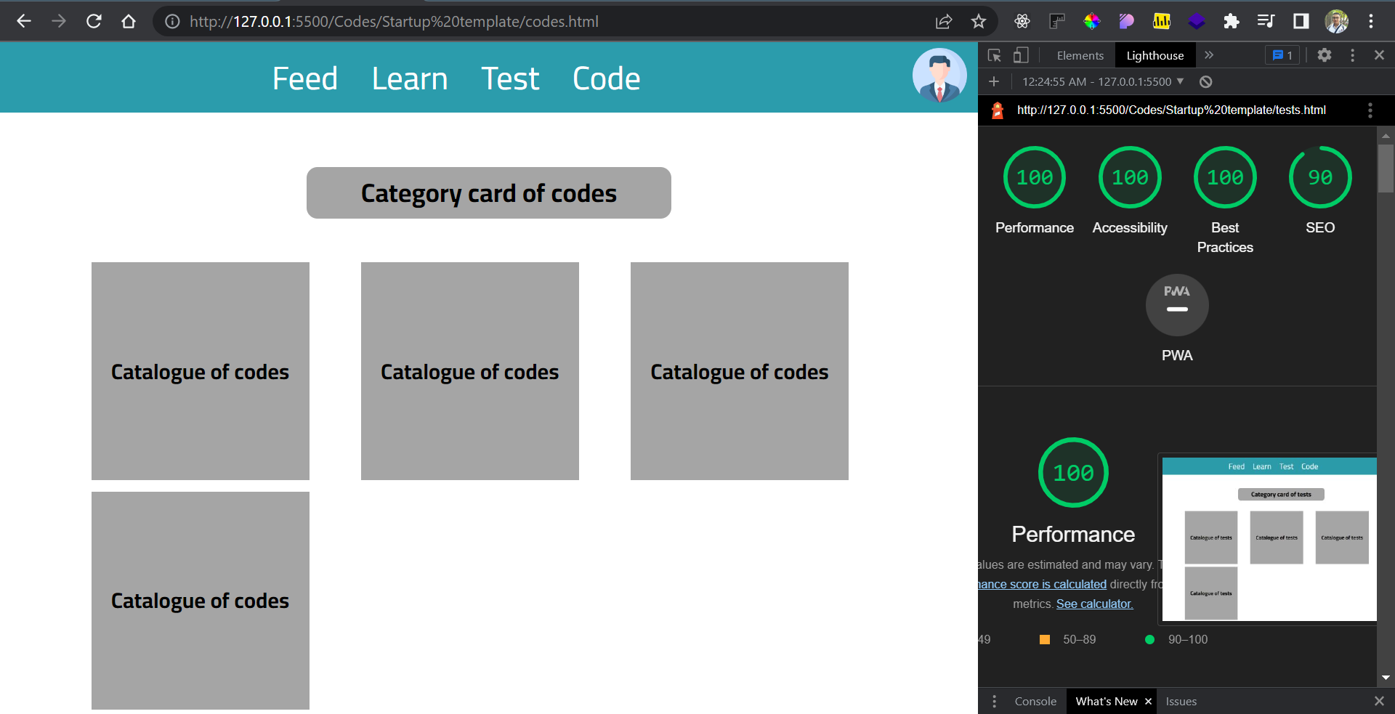

Note : about light house report all the percentages are very good and match the best practice of building UI for pages

Note : Accessibility will increase after host the website on a real server or hosting service.

-Summary-

Building and testing the UI of (Ambilio social-learning platform) has been done -with the ability to update and add new features in the future- by **ALI HSAINO** under the guidance and instruction of **VAIBHAV KUMAR sir** the CEO of **AMBILIO** company.

**This project includes 7 web pages :**

1. Sign-up page : the page where the new user can register on the platform.
2. Log-in page : the page where the old user can log-in to his personal account on the platform.
3. Feeds page: the page where users can learn from the platform users’ experience and share their knowledge on the platform.
4. Profile page: the page where the user can update and add new information about him to increase his experience rate on the platform..
5. Courses page : the page where the user can find his taken courses and new courses on the platform.
6. Tests page : the page where the user can take tests to increase his skills, knowledge and experience in a specific field.
7. Codes page : the page where the user can start coding with his coursemates and debug his code.

**Platform objective :**

Creating a social-learning platform to connect all knowledge seekers around the world and implementing new features together.

**Knowledge gained during developing this project :**

During the development stages which I passed while developing this project, I learned how to implement,optimize and test the Web pages to serve the main objectives of the website which I work on.

As a Front-end intern at **AMBILIO company**, I gained a lot of knowledge about different fields in the programming field, especially in (Web development, Machine learning) fields under **VAIBHAV KUMAR** sir guidance, I am looking forward to a new opportunity to work on another project at **AMBILIO company.**



**AMBILIO company**  **ALI HSAINO**